**Technical Memorandum 4.2: Tour-Based University Student Travel Model Development and Use**

|  |  |
| --- | --- |
| **Prepared for:**  LCOG University Model Development Team |  |
| **Prepared by:**  Parsons Brinckerhoff  400 SW 6th Ave, Suite 802 Portland, Oregon 97204 | **PB Logo RGB.jpg** |

**Jan. 2014 (Working Version)**

Table of Contents

Introduction 5

Model Components 6

Survey Data Processing 9

Data Cleaning 9

Tour and Trip File Generation 10

Inputs and Long Term-Models 11

Accessibilities 12

Residential Location Choice 15

Population Synthesis 21

Car Ownership Model 23

Mandatory Tour Destination Choice Models 26

Work Tour Destination Choice 27

Estimation of Daily and Tour Level-Models 33

Tour Frequency Models 33

Non-Mandatory Tour Destination Choice Models 36

Maintenance Tour Destination Choice 36

Discretionary Tour Destination Choice 41

Tour Time-of-Day Choice 46

Tour Mode Choice Model 49

Stop Level Models 54

Intermediate Stop Frequency Model 55

Intermediate Stop Purpose Model 56

Intermediate Stop Location Choice Model 58

Stop Departure Time Choice Model 68

Trip Mode Choice Model 68

University Model User’s Guide 73

Input Files 73

Output Files 80

Table of Tables

Table 1: Markets in University Accessibilities 14

Table 2: Purposes University Accessibilities 14

Table 3: Frequency Distribution of Distance from Home to University 15

Table 4: University of Oregon Student Residential Location Choice Model Estimation Results 16

Table 5: Residential Location Choice Calibration Constants 20

Table 6: LCOG University Car Ownership Model Estimation Results 24

Table 7: Auto Ownership Calibration Targets 25

Table 8: Auto Ownership Calibration Constants 25

Table 9: Frequencies on Students with Work Tours 27

Table 10: Work Tour Destination Choice Model Estimation Results 28

Table 11: Work Location Choice Calibration Targets 30

Table 12: Work Location Choice Calibration Constants 31

Table 13: Tour Frequency Distribution for Group Quarters Households 33

Table 14: Tour Frequency Distribution for Off-Campus Non-Family Households 34

Table 15: Tour Frequency Distribution for Off-Campus Family Households 35

Table 16: Frequency of Distance to Chosen Maintenance Tour Destinations 37

Table 17: Maintenance Tour Destination Choice Model Estimation Results 38

Table 18: Maintenance Tour Location Choice Calibration Targets 39

Table 19: Maintenance Tour Location Choice Calibration Constants 40

Table 20: Frequency of Distance to Chosen Discretionary Tour Destinations 42

Table 21: Discretionary Tour Destination Choice Model Estimation Results 42

Table 22: Discretionary Tour Location Choice Calibration Targets 44

Table 23: Discretionary Tour Location Choice Calibration Constants 45

Table 24: Tour Mode Choice Observations by Tour Purpose and Auto Ownership 49

Table 25: Tour Mode Choice Estimation Results 51

Table 26: Tour Mode Choice Calibration Targets 52

Table 27: Tour Mode Choice Calibration Controls 53

Table 28: Tour Mode Choice Calibration Constants 53

Table 29: Tour Mode Choice Calibration Results – Absolute Difference in Student Totals 54

Table 30: Tour Mode Choice Calibration Results – Absolute Difference in Shares 54

Table 31: Stop Pattern Frequency by Tour Purpose 55

Table 32: Number of Stop Records by Stop Purpose 59

Table 33: Intermediate Stop Destination Choice Model (Impedance Variables) 62

Table 34: Out of Direction Distance Trip Frequency by Tour Purpose 63

Table 35: Work Stop Location Choice Calibration Constants 65

Table 36: University Stop Location Choice Calibration Constants 65

Table 37: Maintenance Stop Location Choice Calibration Constants 66

Table 38: Discretionary Stop Location Choice Calibration Constants 67

Table 39: Trip Mode Shares by Tour Mode for Non-University Tours 69

Table 40: Trip Mode Shares by Tour Mode for University Tours 69

Table 41: Trip Mode Choice Calibration Constants for Non-University Tours 70

Table 42: Trip Mode Choice Calibration Constants for University Tours 70

Table 43: Trip Mode Choice Absolute Difference (Model – Survey) for Non-University Tours 71

Table 44: Trip Mode Choice Share Difference (Model – Survey) for Non-University Tours 71

Table 45: Trip Mode Choice Absolute Difference (Model – Survey) for University Tours 71

Table 46: Trip Mode Choice Share Difference (Model – Survey) for University Tours 72

Table 47: Transit Ridership Comparison Model vs. 2011 On Board Survey 72

Table 48: Data Inputs 74

Table 49: TAZ Data File Fields 74

Table 50: Level-of-Service Skims 75

Table 51: UECs and Observed Probability Distributions 78

Table 52: Program Files 80

Table 53: Accessibilities file fields 81

Table 54: Household file fields 82

Table 55: Household building type 82

Table 56: Person file fields 83

Table 57: Tour file fields 83

Table 58: Trip file fields 84

Table 59: Occupation codes 85

Table 60: Work status codes 85

Table 61: Student status codes 85

Table 62: Person type codes 85

Table 63: Purposes 86

Table 64: Time periods 86

Table 65: Modes 88

Table of Figures

Figure 1. Major University Travel Model System 8

Figure 2: Residential Location Choice Probability by Distance from the University 18

Figure 3: Residential Location Choice Distance Length Frequency 19

Figure 4: Residential Location Choice Model Results 20

Figure 5: University Student Residential Choice and Population Synthesis Procedure 22

Figure 6: No Auto Calibration Results 26

Figure 7: Work Location Choice Probability Distance Decay Functions 30

Figure 8: Work Tour Destination Choice Model Calibration 32

Figure 9: Maintenance Tour Destination Choice Probability Distance Decay Functions 39

Figure 10: Maintenance Tour Destination Choice Model Calibration 41

Figure 11: Discretionary Tour Destination Choice Probability Distance Decay Functions 44

Figure 12: Discretionary Tour Destination Choice Model Calibration 46

Figure 13: Work Tour Departure, Arrival, and Duration Time Distribution 47

Figure 14: University Tour Departure, Arrival, and Duration Time Distribution 47

Figure 15: Maintenance Tour Departure, Arrival, and Duration Time Distribution 48

Figure 16: Discretionary Tour Departure, Arrival, and Duration Time Distribution 48

Figure 17: Tour Mode Choice Nesting Structure 50

Figure 18: Stop Frequency by Tour Purpose 56

Figure 19: Work Stop Frequency Distribution 57

Figure 20: University Stop Frequency Distribution 57

Figure 21: Maintenance Stop Frequency Distribution 58

Figure 22: Discretionary Stop Frequency Distribution 58

Figure 23: Stop Location Choice Deviation Distance Decay Function 63

Figure 24: Work Stop Location Choice Calibration 65

Figure 25: University Stop Location Choice Calibration 66

Figure 26: Maintenance Stop Location Choice Calibration 67

Figure 27: Discretionary Stop Location Choice Calibration 68

# Introduction

This document describes the estimation of a Tour-Based Model (TBM) system for University Student Travel. This model describes the residential location choice and travel patterns of students of major universities, typically with enrollment levels over 5,000 full-time students with a significant portion of students who relocated to the region specifically to attend school. The model is not expected to be used for students of community colleges or vocational schools whose attendees are primarily drawn from existing residents. The majority of university students represented in the University Model live in group quarters and non-family households, and have travel patterns that are largely independent of other household members and/or roommates. Students of major universities typically have lower auto ownership rates than other households, and therefore greater shares of transit and non-motorized mode usage. Their residential patterns are often unique, with residential clustering around the university campus. For these reasons, a special university travel market model is being designed and developed for use in urban areas with major universities, such as the University of Oregon in Eugene and Oregon State University in Corvallis. An online travel survey of 1,240 University of Oregon students designed by Portland State University and administered by Lane Council of Governments was used for model development. The survey also contains information on University of Oregon faculty and staff but it is expected that the usual residential travel models will adequately address those markets.

The Major University travel models are designed as simple tour-based models, which are characterized by the following considerations:

1. A micro-simulation of travel using a fully-disaggregate student population and a Monte Carlo discrete choice application paradigm wherein a database of students are explicitly represented, and travel choices are modeled explicitly for each student.
2. Tours are used as fundamental unit of travel. A tour is a series of trips starting and ending at home. Tours have an anchor location (home), a primary destination (work, school, or some other dominant out-of-home activity) and zero or more intermediate stop locations. The use of a tour as the unit of travel allows the model system to predict activity locations, modes, and times of trips on tours consistently.
3. The tour-based modeling approach is simple, in that tours are modeled independently of each other. They are not scheduled into a daily activity pattern at a person level, nor are there interactions among household members. This is a key differentiating characteristics between a tour-based model and an activity-based model. In an activity-based model, tours or activities are scheduled such that no person can be in more than one place at the same time, and typically the number and schedule of higher-priority activities influence the number and schedule of lower-priority activities. Activity-based models also seek to coordinate travel across household members.

The tour-based models micro-simulate the travel patterns of University of Oregon students. The tour-based framework retains many of the advantages of an activity-based model (ABM) while greatly simplifying the model system (see Figure 1). In this model system, students generate tours and then tours are modeled independently without fitting them into an over-arching daily activity schedule. Many model components are statistically estimated based upon the data collected (green shaded boxes), while other model components utilize observed frequency distributions from the survey data in order to reduce development cost and time required (blue shaded boxes). Finally, some models are asserted and calibrated to match the travel patterns revealed in the University of Oregon student travel survey (orange shaded boxes). This approach offers the following advantages as compared to a traditional trip-based model:

* 1. More accurate residential location: A residential location choice model predicts student location based upon distance from university and housing stock, with specific group quarters populations based upon university estimates and forecasts.
  2. Consistency of activity locations and modes used on tours: The models incorporate constraints such that the locations of intermediate stops on tours are consistent with the chosen tour mode.
  3. Consistency between home and out-of-home locations on tours: The intermediate stop locations are selected based on out-of-direction cost based upon the home and primary activity location.
  4. The model system incorporates and responds to many socio-economic and level-of-service variables due to the use of micro-simulation of tours as opposed to an aggregate four-step model framework

The tour-based model system contains a number of components (residential location choice, tour and stop destination choice, tour mode choice) that can be easily integrated with an activity-based model such as the Coordinated Travel – Regional Activity-Based Model Platform (CT-RAMP). The model is implemented in Java using Parsons Brinckerhoff’s Common Modeling Framework, a library of Java classes written specifically to implement travel demand models.

## Model Components

The general description of each model component follows the flow chart in Figure 1

1. Input creation: A synthetic student population is created for the region.
   1. Residential location choice: A probability is generated for off-campus students to choose to live in each TAZ.
   2. Population synthesis: A synthetic student population is generated by UrbanSim for the model scenario (some specific land-use\year combination) using the residential location choice model probabilities.
   3. Accessibilities: A set of origin-based accessibilities are calculated for each TAZ and segment to be used in tour generation models. These accessibilities take the form of destination-choice logsums, but can be segmented by specific modes (walk or transit-only for example) as well as market segment (0 auto versus auto insufficient versus auto sufficient) and tour purpose (maintenance versus discretionary).
2. Long Term Models
   1. Car ownership: The number of autos is determined for each household.
   2. Work\School location choice: The work TAZ for each worker and the school TAZ for each student is predicted.
3. Daily and Tour Level Models: These models predict tour frequency, primary destination, outbound/return time period, and general or preferred tour mode. They are segmented into mandatory and non-mandatory models.
   1. Tour Frequency: The exact number of work, university, maintenance, and discretionary tours is predicted by simulating from observed probability distributions for each segment (group quarters, students in non-family households, students in family households) and worker status (worker versus non-worker).
   2. Mandatory tour models: Mandatory purposes are tours made for work or school.
      1. Tour Destination choice: Each tour is assigned a primary destination, based on the coefficients estimated through a multinomial logit model.
      2. Tour Time of Day: Each tour is assigned a departure and arrival half-hour period, based on probability distribution that varies by tour purpose.
      3. Tour Mode Choice: Each tour selects a preferred primary tour mode, based on the coefficients in an asserted nested logit model.
   3. Non-Mandatory tour models: Non-mandatory purposes are tours made for purposes other than work or school, such as escort, shopping, recreational, or eating-out.
      1. Tour Destination choice: Each tour is assigned a primary destination TAZ, based on the coefficients estimated through a multinomial logit model.
      2. Tour Time of Day: Each tour is assigned a departure and arrival half-hour period, based on probability distribution that varies by tour purpose.
      3. Tour Mode Choice: Each tour selects a preferred primary tour mode, based on the coefficients in an asserted nested logit model.
4. Stop Models
   1. Stop Frequency Choice: Each tour is attributed with a number of stops in the outbound direction and in the inbound direction, based upon sampling from a distribution.
   2. Stop Purpose: Each stop is attributed with a purpose, based upon sampling from a distribution.
   3. Stop Location Choice: Each stop is assigned a location based upon an estimated multinomial logit model
   4. Stop Departure Choice: Each stop is assigned a departure time-period (half-hourly) based upon sampling from a distribution.
5. Trip Level Models
   1. Trip Mode Choice: Each trip within the tours selects a preferred trip mode, based on an asserted nested logit model.
   2. Trip Assignment: Each trip is assigned to the appropriate time-of-day specific network.

Figure 1. Major University Travel Model System



# Survey Data Processing

The University of Oregon student travel survey data was collected through an online system and processed by staff at LCOG to combine data from the two different survey phases. Once the data from each phase was combined, however, there was still additional processing required. There were three stages to that processing: 1) eliminating records not useable in the model, 2) identifying missing data that could be fixed quickly, and 3) identifying missing data that required additional work to fill in. Once the data was cleaned and missing records were filled in, Microsoft SQL codes were used to process the survey records into tour and trip files used in the model estimation process.

## Data Cleaning

Before the model estimation process could begin, the University of Oregon student travel survey data had to be processed to ensure that only student weekday records were used and to ensure that each student in the survey reporting a trip completed a full tour to and from the home location. This required multiple stages of data cleaning and an additional step to estimate activity duration for some trips with missing time data.

### Unusable Records

The first two stages of processing the data were to remove non-student records and weekend records. The travel patterns for faculty and staff at the university are appropriately handled by the other models. This model is specifically focused on university student travel, so including faculty and staff would create error in the models. Additionally, weekend travel patterns are very different from weekday travel. During the weekdays students travel primarily for classes and work, but on the weekends there are no classes, significantly altering the set of tours that students make.

Once the faculty and staff and weekend records were removed there were two additional categories of trips and people that had to be removed from the input file. First, students whose home location was outside the LCOG region were removed. The purpose of this work is to generate student trips that can be added to the regional model, so students not living in the region should not be included in the model estimation or application. Second, student that made no trips during the day were removed from the travel dataset, but they were kept in the person dataset. After processing they were reported as students who made no tours during the day.

### Simple Missing Data

While many of the changes made as a result of missing data were more complex, the change was simple for students missing the start or end time for an activity who have enough other activity start and end times. If the start time of an activity was missing, the mode used to reach that activity location and the location of that activity and the previous one were used to find the estimated travel time based on skims from the regional model. That travel time was then added to the previous activity’s end time to calculate the expected arrival/start time that was missing for that activity. If the end time of an activity was missing, the location of that and the next activity as well as the mode used to arrive at the next activity were used to find the appropriate skims and estimate the travel time. The travel time was then subtracted from the start time of the next activity to estimate the missing end time.

### Complex Missing Data

There were two categories of missing data for which the activity duration had to be estimated: students that did not report a home location at the start or end of the travel day, and students with time data missing that could not be estimated using only skims. The records for students with a missing home activity at the start or end of the day were modified to add the home location. Unfortunately, the start time was not reported for the first activity of the day in the survey, and the end time was not reported for the last activity. Therefore, in order to estimate the start or end time of the missing home activity, the duration of the original start or end activity had to be estimated. Once the missing activity duration was estimated skims were used to find the expected travel time to or from the home location. There were also records missing too many travel times to estimate the missing times using only skims. The same procedure was used for all of these to estimate the activity durations that could provide the missing activity start and/or end times.

The missing activity durations were estimated based on a probability distribution of activity durations from the processed survey data. These probability distributions were calculated by time of day (of the start and end time that was there in the model), whether the start or end time was missing, and activity purpose. Expected activity duration times were sampled from the probability distribution for 30-minute increments. Since 30 minutes is the time increment used in the time-of-day choice model, finer temporal resolution for the activity duration sampling was unnecessary. Once the activity duration was sampled for each of the activities with missing times, the resulting start or end time was calculated, and the records were modified accordingly. Once this was done, the student activity records were ready to be processed into trip and tour records.

## Tour and Trip File Generation

In order to obtain the tour and person data used in model estimation, the travel activity data had to be processed into trips and tours. First, the change mode activities had to be combined into one activity from the start location to the end location with a combined trip mode (walk changing to local bus would become walk to local bus). Then, the trips were processed into tours with home as the anchor location and the primary destination chosen based on a combined weighting of distance from home and activity purpose. The processes of assigning tour and trip modes and assigning the primary destination and tour purpose are described below.

### Tour and Trip Mode

In the first stage of the trip mode linking, the change mode activities were removed, and the descriptions of the mode for each activity were combined. (i.e. A change mode activity with mode walk followed by a school activity with mode BRT would become a school activity with mode walk-BRT.) This trip linking was the first stage, but additional processing was required to interpret the series of mode names as one of the standard modes: Drive Alone, HOV2, HOV3+, Walk, Bike, Walk to Local Bus, Walk to BRT, Bike to Local Bus, Bike to BRT, PNR Local Bus, PNR BRT, KNR Local Bus, KNR BRT, and School Bus. The trip mode processing checked for the presence of BRT and Local Bus, assigning a BRT mode if it was present at any point in a transit trip. The code then checked for the access to the transit if a transit mode was present, using “Driver” and “Passenger” to indicate whether a drive to transit mode was PNR or KNR. For those trips without an access mode for transit, the default access mode was Walk. If transit was not found in the trip mode but HOV3+ was found, the mode was set to HOV3+, and if transit and HOV3+ were not found in the mode but HOV2 was found, the mode was set to HOV2.

The hierarchy for choosing the tour mode based on the mode of each trip included in the tour is shown below:

|  |  |
| --- | --- |
| **Rules for coding tour mode:** | |
| If any trip on tour is PNR, tour mode is PNR | |
| else if any trip on tour is Bike-transit, tour mode is BNR | |
| else if any trip on tour is KNR, tour mode is KNR | |
| else if any trip on tour is Walk-Transit, tour mode is Walk-Transit | |
| else if any trip on tour is school bus, tour mode is school bus | |
| else if any trip on tour is bike/moped, tour mode is bike/moped | |
| else if any trip on tour is taxi, tour mode is taxi | |
| else if any trip on tour is shared-3+, tour mode is shared-3+ | |
| else if any trip on tour is shared-2, tour mode is shared-2 | |
| else if any trip on tour is SOV, tour mode is SOV | |
| else if any trip on tour is walk, tour mode is walk | |
| else tour mode is other |  |
| **Then, for transit modes (walk-transit, PNR-transit, KNR-transit):** | |
| If any trip on tour was made by rail, tour mode is rail within access mode | |
| else if any trip on tour was made by BRT bus, tour mode is BRT bus access mode | |
| else tour mode is local access mode |  |
| **Then, for auto modes (SOV, Shared-2, Shared 3+)** | |
| If any trip on tour was made by toll, tour mode is pay within occupancy | |
| else tour mode is free within occupancy |  |

Using these rules, the tour modes were coded based on the trip modes for all trips in the tour.

### Tour Purpose

The primary destination and tour purpose were selected based on the trip purposes and the distance of each trip from the home location. A matrix was used to score each trip based on the purpose and distance, with work and university trips having the highest priority as well as trips further from home having higher priority, with the assumption that the furthest destination would be the primary destination and all other locations would be stops between home and the primary destination. Once the primary destination was selected, the purpose of the trip to that location was used as the tour purpose. Additionally, any trips between home and that primary destination were re-coded as inbound or outbound stops depending on whether they happened after the student reached the primary destination or before.

# Inputs and Long Term-Models

This section describes the estimation of each long term model component including the estimation dataset, the coefficients and t-statistics of the main explanatory variables used, the utility structure if applicable, and a summary of the findings of the estimation results.

## Accessibilities

Accessibility measures are primarily needed to ensure that the upper-level models in the model hierarchy, such as car ownership, are sensitive to improvements of transportation Level-of-Service (LOS) as well as changes in land use. Accessibility measures are needed since it is infeasible to link all model choices by full logsums. Accessibility measures play the role of simplified logsums used in upper-level models instead of full logsums (which is computationally infeasible to calculate over all modes, outbound/return time-of-day period combination, and destinations for each possible tour). Accessibility measures ensure “upward integrity” of the model structure.

Accessibility measures should be created in order to reflect the opportunities to implement a travel tour for a certain purpose from a certain origin (residential or workplace). They are used as explanatory variables in the upper level models and the corresponding coefficients are estimated along with the coefficients for person and household variables. Since they only represent a proxy for full logsums there is no guarantee that the entire model would exhibit a completely consistent sensitivity to any transportation LOS improvements. For example, one may reasonably expect that if transit is improved in a certain area (assuming the highway and non-motorized modes stay the same) it would generate more tours and trips in general but the extra travel would be implemented by entirely by transit (in addition, some portion of the previously implemented trips would shift to transit as the result of mode shift). This is not always the case with simplified accessibility measures.

Each accessibility measure is stored as a vector of values (one value per zone). In application, accessibility measures are recalculated at each global iteration as part of the overall equilibration process.

General Form of Accessibility Measures

Accessibility measures have the following general form:

**,**

Equation 1

Where:

 = origin and destination zones,

 = accessibility measure calculated for each origin zone,

 = attraction size variable for each potential destination,

 = cost of travel between origins and destinations,

 = dispersion coefficient.

In this form, an accessibility measure is essentially a sum of all attractions in the region discounted by the travel impedance. It can be equivalently viewed as a destination choice logsum. The dispersion coefficient expresses a sensitivity of the given type of activity to travel cost, i.e. travelers’ tolerance to longer travel times in order to participate in the given activity. Larger dispersion coefficients reflect a greater sensitivity to travel times and costs, reflecting more localized activity types.

In the form of equation 1 (i.e. destination choice) logsum, an accessibility measure can be linearly included in a utility function of an upper-level model. To preserve consistency with the random-utility choice theory, the coefficient for any accessibility measure should be between 0 and 1; though it is not as restrictive as in a case of a proper nested logit model.

Accessibility measures are operationalized in four dimensions:

* Specification of **market** **segmentation** (i.e. the number of different measures for different activity types that are going to be used in the model). In the university model, we build accessibilities for two auto sufficiency categories : auto unavailable and auto available. Plus, we build one set of accessibilities with no auto sufficiency segmentation.
* Specification of **size variables,** i.e. zone attractors for the given segment that are normally modeled as a combination of certain LU variables (like for tour and trip destination choice). Accessibilities are built for each of four tour purposes in the university model: Work, University, Maintenance, and Discretionary, using the size terms that were estimated in tour destination choice for each model. In addition, we build one accessibility term for households and one term for all employment.
* Specification of **transportation cost**. Two major approaches can be taken for calculation of transportation cost: 1) mode-specific, where an accessibility measure is calculated separately for each main mode; 2) mode-averaged, where all modes are converted into a single measure. Accessibilities for the university model are calculated for each of the following specific modes: single-occupant vehicle (SOV), high-occupant vehicle (HOV), walk-transit, and walk. Accessibilities are also calculated for averaged modes according to a logsum with market-specific modal constants for each market as listed above.
* Specification of **time-of-day (TOD)** period for each measure. Transportation cost is also dependent on time-of-day (TOD) period. To avoid the complexity associated with calculating logsums over TOD periods, normally a certain representative TOD period is assumed for each accessibility measure. Alternatively, several accessibility measures for each TOD period can be statistically tested in the model estimation where the best one is chosen. However, it is normally difficult to include several accessibility measures of the same type calculated for different TOD periods in the same model because of correlation between them. In the University model, accessibilities are calculated for the midday period in the outbound direction and the PM peak period in the return direction.

The dispersion coefficient, as well as other parameters embedded in the size variable and transportation cost function, can be either estimated (which means an estimation of a simplified mode choice model and/or destination choice model) or asserted based on the normative values of the parameters known from the previously estimated mode and destination choice models. In the university model, the dispersion coefficient is asserted at 1.0.

The combination of the dimensions listed above results in 28 accessibilities; seven combinations of market and mode as shown in Table 1, by four purposes as shown in Table 2. Various combinations of these accessibilities were tested in model estimation for upper-level model components such as student residential choice and auto ownership. The significant accessibilities are retained in the final model, but the software creates all accessibilities in case some other variables are found to be significant in later model implementations.

Table 1: Markets in University Accessibilities

|  |  |
| --- | --- |
| **Market** | **Description** |
| 1 | SOV |
| 2 | HOV |
| 3 | Walk-Transit |
| 4 | Walk |
| 5 | 0 Autos |
| 6 | Autos > 0, Autos < Adults |
| 7 | Autos > 0, Autos >= Adults |

Table 2: Purposes University Accessibilities

|  |  |
| --- | --- |
| **Market** | **Description** |
| 1 | Maintenance |
| 2 | Discretionary |
| 3 | All households |
| 4 | All employment |

## Residential Location Choice

The residential location choice model predicts the home location for the students based on the survey data. This model is applied before the population synthesis and provides the probability of students of each type choosing to live in each TAZ.

**Utility Structure**

The utility () of choosing a home location (j) for an individual (n) in zone (i) is given by

 Equation 2

Where, is the size variable for home zone *j*,  represents the various distance terms (linear, log, and squared), and  represent person or household characteristics for individual n and is used for creating interaction variable with distance terms.

### Estimation Dataset

In the University of Oregon Student Travel Survey there were 646 observed university tour records. Since the residential location is based primarily on the location relative to the university for students, only university tours were included in the model estimation. Table 3 below shows the frequency distribution of the distance between home and university for the weighted student survey dataset. Most students in the survey live within 6 miles of the University of Oregon campus, which impacted the coefficients estimated on distance terms in this model.

Table 3: Frequency Distribution of Distance from Home to University

|  |  |  |  |
| --- | --- | --- | --- |
| **Distance (miles)** | **Count** | **Percentage** | **Cumulative Percentage** |
| 0 | 8,044 | 41% | 41% |
| 1 | 5,310 | 27% | 67% |
| 2 | 2,031 | 10% | 78% |
| 3 | 1,976 | 10% | 88% |
| 4 | 1,148 | 6% | 93% |
| 5 | 348 | 2% | 95% |
| 6 | 379 | 2% | 97% |
| 7 | 344 | 2% | 99% |
| 8 | 171 | 1% | 100% |
| 9 | 18 | 0% | 100% |
| 10 | 0 | 0% | 100% |
| 11 | 31 | 0% | 100% |
| 12 | 0 | 0% | 100% |
| 13 | 0 | 0% | 100% |
| 14 | 0 | 0% | 100% |
| 15 | 0 | 0% | 100% |
| Total | 19,798 | 100% | 100% |

### Main Explanatory Variables

The following variables were examined and proved to be significant in the utility functions:

* Walk to Transit Logsum for Discretionary Tours: The walk-transit logsum is an origin-based or destination-choice type of logsum that measures the accessibility of all discretionary activities by walk-transit mode of travel (see Equation 1).
* Impedance between potential home locations and the University (represented by zone 398)
  + Linear distance (capped at a maximum distance of 12 miles)
  + Natural Log of distance (capped at a maximum distance of 12 miles)
* Size Terms: There are 3 main types of housing used to estimate size terms in this model:
  + Multi-Family Households
  + Single-Family Households
    - Single-Family Households interacted with family person type
  + Duplexes

The number of variables that could be tested in this model was limited by the fact that it must be applied before the population synthesis. Since this model is applied before the population synthesis, socioeconomic person characteristics are not available during the application. Therefore, this model is limited to include only distance from the university, household-type category (family or non-family), and TAZ characteristics. Additionally, the walk-to-transit logsums from the discretionary choice model used were based on a simplified mode choice model that used only data available before the population synthesis procedure. All distances were also capped at 12 miles. There were no observations beyond 12 miles from campus in the survey, and the coefficients estimated on the distance terms displayed unrealistic effects when not capped.

### Model Estimation Results

The residential location choice model estimation results are summarized in Table 4.

Table 4: University of Oregon Student Residential Location Choice Model Estimation Results

**Observations:** 646

**Final log likelihood:** -3148

**Rho-Squared (0):** 0.2503

|  |  |  |
| --- | --- | --- |
| **Utility Function Variables** | **Coeff** | **T-Stat** |
| Discretionary Walk to Transit Logsum | 0.087 | 3.05 |
| Distance | -0.685 | -5.98 |
| Distance Natural Log | -0.162 | -0.48 |
| Distance*Family | 0.545 | 8.59 |
| *Size Function[1]* |  |  |
| Multi-family Households | 1.000 |  |
| Single-family Households | 0.625 | -2.60 |
| Single-family Households*Family | 0.295 | -1.47 |
| Duplexes | 0.848 | -0.30 |

### Model Estimation Findings:

* The walk-to-transit logsum variable shows the impact of walk-to-transit accessibility on the choice of where to live. The coefficient on the walk-to-transit logsum is between 1 and 0, but it is very small. The walk mode to discretionary activities logsum was also tested, but the coefficient was negative.
* The distance variables show the relationship between distance from the University and probability of choosing to live in a given TAZ. Figure 2 shows a graphic of the probability of choosing a home TAZ as the distance from the university increases, and it shows that as the distance increases beyond 5 miles, the probability quickly decreases to approximately zero. This is expected, since Table 1 shows that very few people in the University of Oregon Student Travel survey chose to live more than 5 miles from the campus.
* The distance interacted with family variable indicates whether the impact of distance on residential location choice is different for family and non-family households. The positive coefficient demonstrates that students living in family households live further from campus than those in non-family households. This is an expected result since students living in family households may not make the residential location choice decision simultaneously with the decision to attend school at the University of Oregon, and therefore their home location is influenced by other factors such as other school locations and/or work locations.
* Size term effects:
  + Multi-family households is the base category for the size term, and has the largest coefficient.
  + Duplexes had a similar impact on the home location choice to multi-family households, while single-family households showed a smaller impact.
  + Single-family households were more important to students living with a family than non-family students.

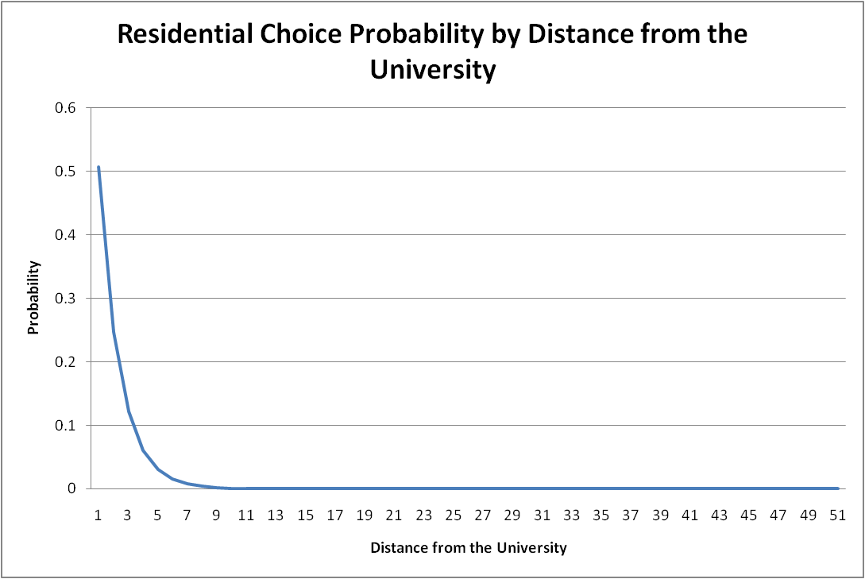

Figure 2: Residential Location Choice Probability by Distance from the University

### Calibration Targets

The data for the calibration targets were sourced from 911 address database for student addresses on file. The dataset has the address location of 15,308 students – this included the address records of students who live in group quarters setting (such as boarding/rooming houses and college dormitory). Such records were processed out and a total of 11,004 valid student addresses remained. These were geocoded onto the LCOG TAZ layer and the number of students in each TAZ was determined using spatial join. The 911 dataset was known to have a few missing records – hence the totals just derived were scaled up to 19,408 (student enrolment from family and non-family housing as suggested by the survey). These numbers were compared against the modeled values and necessary adjustments were made to better match the observed spatial distribution of the students.[2] The adjustments were derived as logarithm of observed by predicted and adjustments for a new iteration were added to the adjustments applied previously. The model required several iterations of calibration before arriving at the final constants.

Initial model results suggested under-prediction of students in two key TAZs – TAZ number 213 and 648. **TAZ 213** is the “Duck Village” which covers majority of big developments dominated by apartment housing (non-family housing) designed for students. On the other hand, **TAZ 648** has plenty of affordable family housing for students. The estimated model, which relies on distance based utility curve and size terms could not sufficiently capture this high spatial concentration of student housing (this concentration could potentially be better explained by the housing/renting costs in the region – such data was not available when estimating the model). Hence a zone and housing type specific constant was introduced to match the totals in these zones.

### Calibration Results

Next, distance length frequency distributions were plotted – as expected, the linear and the polynomial distance terms resulted in a smooth, monotonically decreasing distance length frequency distributions. However, the observed distribution exhibited a spike in the 2 to 3 miles distance bin. This necessitated the introduction of bin specific constants for the first three distance bin to arrive at a better fit. shows the final modeled distance length frequency compared with the observed frequencies.

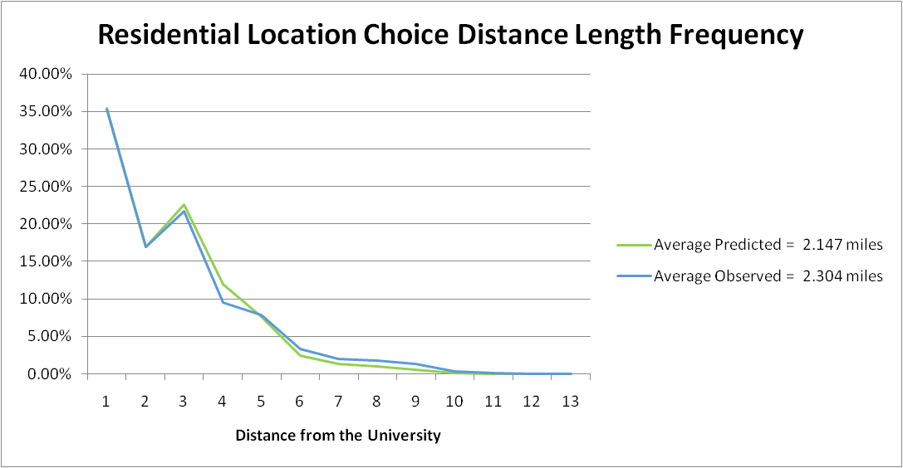

Figure : Residential Location Choice Distance Length Frequency

After making these adjustments, in general, the model seemed to overestimate the students in the Springfield region. Therefore, a constant for the Springfield region was introduced.

To summarize, the calibration of the residential location choice model for the University model involved introducing the following three categories of constants:

* Calibration constants for special TAZs (TAZ 213 and TAZ 648)
* Calibration constants for distance thresholds
* Calibration constants for spatial groups (Springfield Region)

Table 5 shows the final constants applied to the model. Figure 4 is a thematic map showing the difference in observed and the estimated number of students.

Table : Residential Location Choice Calibration Constants

|  |  |  |  |
| --- | --- | --- | --- |
| **Calibration constants** | **Family** | **Non-Family** | **Both** |
| *Calibration constants for special TAZs* |  |  |  |
| TAZ 213 |  | 1.670 |  |
| TAZ 648 | 3.074 |  |  |
|  |  |  |  |
| *Calibration constants for distance thresholds* |  |  |  |
| All TAZ's within 0 to 1 mile distance |  |  | -0.215 |
| All TAZ's within 1 to 2 miles distance |  |  | -0.589 |
| All TAZ's within 2 to 3 miles distance |  |  | -0.275 |
|  |  |  |  |
| *Calibration constants for spatial groups* |  |  |  |
| Springfield region |  |  | -0.530 |

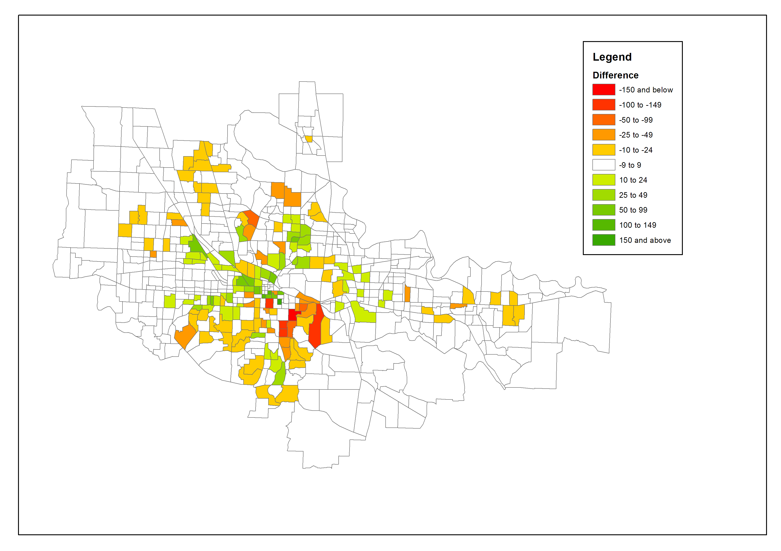

Figure : Residential Location Choice Model Results

## Population Synthesis

The results of the university student residential location choice model are integerized and used as person-level micro-zone (MAZ) constraints in a population synthesis procedure described elsewhere (see Technical Memorandum 2.1: Oregon Population Synthesizer Design and Use). The university student population is generated simultaneously with the non-student population. The following university student segments are explicitly recognized in the population synthesis procedure:

* **Students in group quarters housing:** Group quarters population are constrained to official university estimates of on-campus group quarters housing, plus housing inventory data on fraternity/sorority homes and student-only apartments. Group quarters households have a size of one person per household. These tend to be younger students. This student population is generated outside of the population synthesizer, since there is no chance of double-counting students living in group quarters.
* **Students in off-campus, non-family households:** Students living in non-family households are constrained by the results of the residential location choice model. They are uniquely identified in the Public Use Microdata Sample(PUMS) from which synthetic households are drawn.
* **Students in off-campus, family households:** Family households have at least two household members. University students in this segment are also explicitly controlled based upon the residential location choice model outputs, and PUMS family households containing at least one university student form the pool from which these students are synthesized.

In the Oregon population synthesis procedure, the major university PUMS population is created by doubling the households containing university students and setting their weight to one-half of the previous weight. The doubling of household records with university students is required because PUMS does not identify the university that students attend. However, the synthetic population will identify, for each student record, whether they attend the major university. So, each household containing students is doubled, and one-half of them are coded as attending the major university, the other half are coded as attending some other university. The major university students are subjected to the constraints described above, while the non-major university students are synthesized based upon the rest of the synthetic population control totals described in Memorandum 2.1. The weights are adjusted to one-half their original value so that the sum of the PUMS household and person weights for the region remains undisturbed.

The output from the synthesis procedure is a synthetic household population for each MAZ, containing a sub-population of students at the major university (identified by an extra field in the person file indicating whether each person is a student in the major university). The overall residential location choice and synthesis procedure is shown in Figure 5.

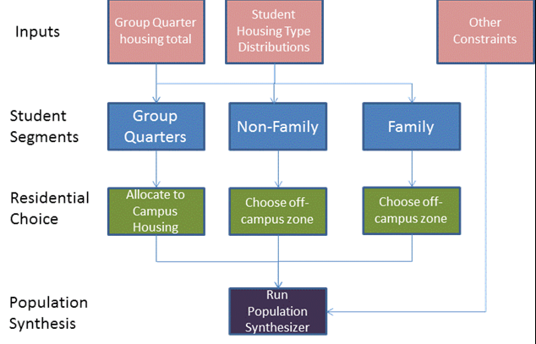

Figure : University Student Residential Choice and Population Synthesis Procedure

## Car Ownership Model

Household car ownership models typically predict the number of autos (including motorcycles, vans, and trucks for personal use) available to a household. However, based on the assumption that students tend to operate independently of one another even when living together, the car ownership model for University Travel is a binary choice model which indicates whether or not each student has at least one auto available. Note that this assumption is borne out by the survey data, which indicates relatively low levels of intra-household ride-sharing. In this model, car ownership is a dependent variable derived from the activity needs of the student based on person characteristics and mode-specific accessibilities.

### Estimation Dataset

The estimation dataset included 878 observed students from the University of Oregon Student Travel survey. The accessibilities used in this model were for Discretionary tours for both the calculation of auto dependency and the walk logsums.

### Explanatory Variables and Utility Structure

The following variables were examined and proved to be significant in the utility functions. Note that the explanatory variables are rather limited when compared to other, household auto ownership models, probably because student auto ownership is heavily influenced by variables not specifically related to the student. These include the level of wealth of the household that the student belongs to, and whether or not that household owns extra cars when the student attends school.

**Household Characteristics:**

* Group Quarters household (On-campus or off-campus university-owned group quarters)
* Family household

**Person Characteristics**

* Income: The high income cutoff was selected based on the distribution of income values seen in the survey. The value is much lower than in more general surveys, but students overall tend to have either no income or much lower income due to the fact that the majority of their time is spend in classes or studying.
  + $30,000 and more

Age: The age groups included in the model also separate students early in their college education (under 20 years) from more mature students and graduate students (over 24 years)

* + Less than 20 years old
  + More than 24 years old

**Other:**

* Walk accessibility to discretionary tour destinations
* Auto dependency: The auto dependency variable is calculated using the difference between the single-occupant vehicle (SOV) and the walk to transit mode choice logsum. The logsums are computed based on the household TAZ and a University TAZ (398), and the resulting auto dependency is calculated as shown:

AutoAdvantage = LogsumSOV – LogsumWalkTransit if LogsumSOV > LogsumWalkTransit, else 0

NonMotorizedFactor = 0.5 * (min(max(University Distance, 1.0), 3.0)) - 0.5

AutoDependency = min(AutoAdvantage /3.0, 1.0) * NonMotorFactor

The AutoAdvantage measures the relative attractiveness of using the Drive Alone mode compared to Walk to Transit between the home location and the university. The measure is greater the more accessible the workplace is to home by auto compared to transit with walk access. If transit has a greater accessibility than auto, the difference is capped at 0 (auto has no advantage). The non-motorized factor measures how accessible the university is from home by walking. It ranges between 0 and 1, where 0 is very accessible and 1 is not accessible. The first part of the AutoDependency equation scales the difference in utility between auto and transit to a measure between 0 and 1, where 0 is very auto dependent and 1 is not auto dependent. This is then multiplied by the non-motorized factor, to reflect that even if transit accessibility is poor relative to auto, the auto dependency is lower if the university is within walking distance of home.

### Model Estimation Results

The car ownership model estimation results are summarized in Table 6.

Table : LCOG University Car Ownership Model Estimation Results

**Observations:** 878

**Final log likelihood:** -460

**Rho-Squared (0):** 0.2444

|  |  |  |
| --- | --- | --- |
| **Utility Function Variables** | **Coeff** | **T-Stat** |
| 0 Auto Constant | -2.311 | -2.15 |
| Group Quarters Housing | 1.050 | 5.03 |
| Family | -0.380 | -1.32 |
| High Income | -1.012 | -2.03 |
| Age Less than 20 | 0.175 | 0.82 |
| Age Over 24 | -0.538 | -2.37 |
| Auto Dependency | -0.989 | -1.60 |
| Walk Discretionary Logsum | 0.186 | 1.34 |

### Model Estimation Findings

* The constant on no-auto households is negative, indicating that students have a latent preference for having at least one auto available for travel.
* The Group Quarters Housing variable indicates whether students living in group quarters are more or less likely to not own a car than students living in non-university housing. The positive coefficient shows that students who live in group quarters (on or off campus) are more likely to have no auto than students who do not live in group quarters.
* The family variable indicates whether students living with family are more or less likely than those not living with family to not own a car. The negative family coefficient indicates that students living as part of a family are more likely to own at least one auto.
* The high income variable represents how much more likely high income households are to own no cars than medium and lower income households. The negative coefficient signifies that high income households are more likely to own cars than medium and low income households.
* The age variables indicate whether younger students (less than 20 years old) and older students (over 24 years old) are more likely to own 0 autos. The positive coefficient on younger students shows that students less than 20 years old are more likely to not own an auto than older students. The negative coefficient on older students demonstrates that students over 24 years old are more likely to own at least one car.
* The auto dependency variable represents how much student’s tours are dependent on the auto mode. This variable has a negative coefficient for no auto ownership. This shows that a student is more likely to own a car if they have a strong dependency on using the auto mode for making tours.
* The positive and significant coefficient on walk logsum for discretionary tours indicates that students living in zones that are very walk-accessible to discretionary activities are less likely to own a car.

### Calibration Targets

The calibration targets for auto ownership were derived from the weighted University of Oregon Student Travel survey. The calibration process adjusted the constants for no auto by person type (Group Quarters housing, Off-Campus Non-Family, and Off-Campus Family). The target shares by person type and auto ownership are shown in Table 7.

Table 7: Auto Ownership Calibration Targets

|  |  |  |
| --- | --- | --- |
| **Person Type** | **No Auto** | **Auto Available** |
| Group Quarters Housing | 53.9% | 46.1% |
| Off-Campus Non-Family | 27.3% | 72.7% |
| Off-Campus Family | 15.0% | 85.0% |

As expected, the off-campus students had a higher rate of auto ownership than the group quarters students. The constants were estimated and applied by person-type to the no-auto alternative in the model. At the end of the calibration process, the auto ownership shares by person type from the model exactly matched the weighted survey shares.

### Calibration Results

The final calibration constants are shown in Table 8. The largest change required was in the Off-Campus Family category, and the smallest change was in Group Quarters. Due to the binary nature of the choice in this auto ownership model, the constants were applied only to the no-auto alternative, and no constants were used for the auto available alternative.

Table : Auto Ownership Calibration Constants

|  |  |
| --- | --- |
| **Person Type** | **No Auto** |
| Group Quarters Housing | 0.2803 |
| Off-Campus Non-Family | 0.5046 |
| Off-Campus Family | 0.7639 |

The results of applying the calibration constants are shown in Figure 6 which breaks out the comparison of no-auto ownership shares by person type for the model results (shown in red) and the weighted survey (shown in blue).

## 

Figure : No Auto Calibration Results

## Mandatory Tour Destination Choice Models

The destination choice model predicts the location of the primary activity of the tour, based on mode choice logsums, distance terms, zonal employment and household and person attributes as explanatory variables. A work tour destination choice model was estimated in a multinomial logit form using the ALOGIT software. Since university tours are restricted to only those zones with University of Oregon buildings, the university tour destination choice is based upon the square footage of ‘usable’ space in university TAZs. The university tour destination choice model was not estimated.

**Utility Structure**

The utility () of choosing a destination (j) for an individual (n) in zone (i) is given by



Where, is the size variable for destination zone *j*,  is the mode choice logsum between zone pair *ij*,  represents the various distance terms (linear, log, and squared), and  represent person or household characteristics for individual n and is used for creating interaction variable with distance terms.

### Work Tour Destination Choice

The work destination choice model predicts the usual work location for full-time and part-time workers. This model is one of the first applied in the model chain.

Note that the work tour destination choice models were estimated using the full set of potential TAZs as alternatives. However, in application, a two-stage approach is used where a sub-set of 30 alternatives are sampled from the full set of zones using a simpler destination choice model with only a distance coefficient and a size term. Then, the full model is run for all 30 sampled alternatives. This two-stage procedure is employed in order to decrease the computational time for destination choice, as it would be computationally infeasible to calculate a full mode choice logsum for each tour and each TAZ.

#### Estimation Dataset

In the University of Oregon Student Travel Survey there are 135 observed work tour records. Table 9 below shows the working adults in surveyed households by person type and year in school. Although only 128 students reported making a work tour on the day that they were surveyed (some made multiple work tours, resulting in the 135 total work tours), there were 480 students who reported being either a part-time or full-time worker. This may be a result of the fact that the majority of working students in the survey (413 of the 480 workers) only work part-time, and they may not have been working on the day that the survey was performed.

The ratio of males to females reporting work tours was primarily a result of the overall ratio of males to females in the survey responses (30%/68%) and not necessarily an indication that female students have a higher rate of working than male students.

Table 9: Frequencies on Students with Work Tours

|  |  |  |
| --- | --- | --- |
|  | Count | Percentage |
| ***Worker status*** |  |  |
| Full-time | 22 | 17.2% |
| Part-time | 94 | 73.4% |
| Not Working/Unknown | 12 | 9.4% |
| ***Gender*** |  |  |
| Male | 33 | 25.8% |
| Female | 95 | 74.2% |
| Unknown | 0 | 0% |
| ***Year In School*** |  |  |
| Freshman | 6 | 4.7% |
| Sophomore | 7 | 5.5% |
| Junior | 17 | 13.3% |
| Senior | 44 | 34.4% |
| Graduate Student | 54 | 42.2% |
| Unknown | 0 | 0% |
| **Total** | **878** | **100%** |

#### Explanatory Variables

The following variables have been examined and proved to be significant in the utility functions:

* Mode choice logsum
* Impedance between potential work locations and home:
  + Natural Log of distance from home
* Impedance between potential work locations and the University (represented by zone 398):
  + Natural Log of distance from the University
* Distance interacted with person and household characteristics:
  + Year in school interacted with distance from home
    - Freshman/Sophomore
    - Junior/Senior
  + Family interacted with distance from the University
  + Gender interacted with distance from home
* Size Terms: There are 2 work occupation segments included in this model, and each segment has different sensitivities to employment that determine a person’s work location choice
  + Service Employment
  + Other Employment (Total Employment – Service Employment)

Linear and squared formulations were tested for both the distance from home and the distance from the University, however, only the natural log of each distance provided a logical distance decay function. Other variables, such as retail employment, auto ownership interacted with distance, and income interacted with distance, were tested but not found to be statistically significant in this model. The distances from home and the University were both capped at 10 miles based on the observed distances in the survey data.

#### Model Estimation Results

The work destination choice results are summarized in Table 10. As with the residential location choice model, the size term coefficients shown have been exponentiated.

Table 10: Work Tour Destination Choice Model Estimation Results

**Observations:** 133

**Final log likelihood:** -661

**Rho-Squared (0):** 0.2360

|  |  |  |
| --- | --- | --- |
| **Utility Function Variables** | **Coeff** | **T-Stat** |
| Mode Choice Logsum | 0.221 | 0.74 |
| Distance from Home Natural Log | -0.550 | -0.69 |
| Distance from University Natural Log | -3.404 | -7.80 |
| *Year In School* |  |  |
| Freshman/Sophomore*Distance from Home | -0.242 | -0.48 |
| Junior/Senior*Distance from Home | 0.334 | 1.95 |
| *Gender* |  |  |
| Male*Distance from Home | -0.496 | -1.88 |
| *Household Type* |  |  |
| Family*Distance from University | 0.305 | 1.89 |
| *Size Function* |  |  |
| Service Employment | 1.000 |  |
| Other Employment | 0.207 | -5.00 |

#### Model Estimation Findings

* The logsum variable shows the impact of accessibility from the home location on the choice of work tour destination, based upon all modes of transport as measured in the university tour mode choice model. The coefficient on mode choice logsum is positive and between 0 and 1 as expected.
* The distance from home variable measures the distance between home and the workplace location. The natural log of distance was taken as it proved to be the best fit to data, indicating that distance becomes less important at greater distances. This may be because of colinearity with mode choice logsum, or because of an actual non-linear distance effect. The coefficient is negative, but is not significant. It was retained in application after observing that the estimated work tour distance was a bit long compared to observed data.
* The distance from University variables show how much the choice of work location is influenced by the distance from the University. The distance from university has a negative and significant effect, indicating that students would tend to find work locations close to the university if possible.The impact of both distance terms on the work location choice probability is shown in Figure 7. The choice probability is consistently decreasing as the distances from home and the University increase.
* The year in school variable indicates whether Freshmen and Sophomores or Juniors and Seniors tend to look for work closer to home than graduate students. The negative coefficient on Freshmen and Sophomores shows that students in their first two years of college tend to choose work locations closer to home. The positive coefficient on Juniors and Seniors demonstrates that students in their last two years of undergraduate college are willing to travel further from home for work tours.
* The gender variable indicates whether male students have a different value for distance from home than female students for work tours. The negative coefficient suggests that male students are more sensitive to the distance between the work tour location and home than female students.
* The family variable shows the relative sensitivity of students in family households to distance from the university as compared to students in non-family households. The positive coefficient on family and distance from the university indicates that students living as a family are less sensitive to the distance of the work location from the university than non-family students.
* Size term effects:
  + As the category that demonstrated the largest impact, Service Employment was used as the base. Although Retail Employment was tested separately from the “Other” category initially, it did not have a statistically significant impact on its own.
  + Employment in all other categories has a much smaller impact than the service employment, but it does still have some influence over the work location choice.

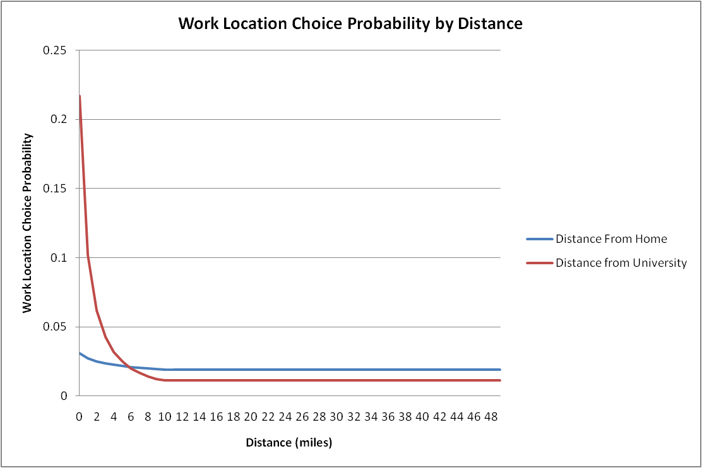

Figure 7: Work Location Choice Probability Distance Decay Functions

#### Calibration Targets

Although there were multiple variables in the work location choice model, the calibration term chosen was the distance between the home and work locations. The distance from home to work was the primary distance term used in the model, so the natural log of the distance from home to work was used in calibrating the model. The calibration targets for work location choice, calculated from the weighted survey data, are shown in Table 11.

Table 11: Work Location Choice Calibration Targets

|  |  |  |
| --- | --- | --- |
| **Distance from Home** | **Count** | **Share** |
| 0 | 8,044 | 40.6% |
| 1 | 5,310 | 26.8% |
| 2 | 2,031 | 10.3% |
| 3 | 1,976 | 10.0% |
| 4 | 1,148 | 5.8% |
| 5 | 348 | 1.8% |
| 6 | 379 | 1.9% |
| 7 | 344 | 1.7% |
| 8 | 171 | 0.9% |
| 9 | 18 | 0.1% |
| 10 | 0 | -- |
| 11 | 31 | 0.2% |
| 12 | 0 | -- |
| 13 | 0 | -- |
| 14 | 0 | -- |
| 15 | 0 | -- |

The calibration was performed using two methods. For the tours less than 2 miles from the home location a calibration constant was asserted to match the survey shares in those categories. For work tours 2 miles or more from the home location, the calibration constant was applied to the natural log of the distance (plus one for consistency with the model). This allowed for the model to more closely match the shares in the first two categories and match the functional shape for all other distances.

#### Calibration Results

The calibration constants at the end of the calibration process are shown in Table 12. The first two constants were applied to any destinations within that distance category, but the other constant was applied to the natural log of the distance.

Table : Work Location Choice Calibration Constants

|  |  |  |
| --- | --- | --- |
| **Distance from Home** | **Calibration Term** | **Calibration Constant** |
| 0 – 1 miles | 1 | 0.4563 |
| 1 – 2 miles | 1 | 0.1725 |
| 2 + miles | LN(Distance + 1) | -0.7028 |

The final calibration results are shown in Figure 8. While there are differences in the shares in some categories, the overall match is close. The average distance between home and work is also within 0.3 miles of the average distance from the weighted survey.

The average distance between home and work in the weighted survey was 2.27 miles, and the average distance from the model output is slightly higher at 2.57 miles. The difference was primarily due to the difficulty in accurately matching the number of work tours between 2 and 4 miles from home.

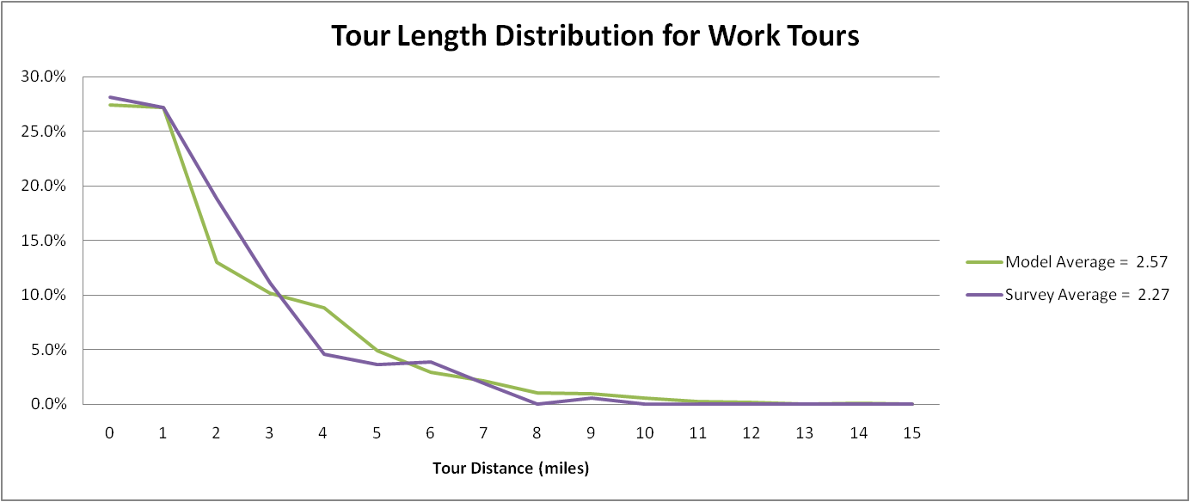

Figure : Work Tour Destination Choice Model Calibration

# Estimation of Daily and Tour Level-Models

This section describes the development and estimation of the daily and tour level model components including the estimation dataset, the coefficients and t-statistics of the main explanatory variables used, the utility structure if applicable, and a summary of the findings of the estimation results.

## Tour Frequency Models

The tour frequency models are applied by sampling from an observed frequency distribution, segmented by student type (group quarters, non-family, and family) and worker status (yes or no). The distributions are shown below for Group Quarters in Table 13, for Off-Campus Non-Family households in Table 14, and for Off-Campus Family households in Table 15.

Table : Tour Frequency Distribution for Group Quarters Households

|  |  |  |  |  |  |
| --- | --- | --- | --- | --- | --- |
| **Worker** | **Work Tours** | **University Tours** | **Maintenance Tours** | **Discretionary Tours** | **Frequency** |
| No | 0 | 0 | 0 | 0 | 0.253683 |
| No | 0 | 0 | 0 | 1 | 0.027203 |
| No | 0 | 0 | 0 | 2 | 0.006801 |
| No | 0 | 0 | 1 | 0 | 0.013602 |
| No | 0 | 1 | 0 | 0 | 0.437474 |
| No | 0 | 1 | 0 | 1 | 0.014969 |
| No | 0 | 1 | 0 | 2 | 0.020403 |
| No | 0 | 1 | 1 | 0 | 0.020641 |
| No | 0 | 1 | 1 | 1 | 0.001367 |
| No | 0 | 1 | 1 | 3 | 0.006801 |
| No | 0 | 1 | 2 | 0 | 0.006801 |
| No | 0 | 2 | 0 | 0 | 0.10717 |
| No | 0 | 2 | 0 | 1 | 0.006801 |
| No | 0 | 2 | 1 | 0 | 0.027203 |
| No | 0 | 3 | 0 | 0 | 0.025144 |
| No | 0 | 3 | 0 | 1 | 0.017136 |
| No | 0 | 4 | 0 | 1 | 0.006801 |
| Yes | 0 | 0 | 0 | 0 | 0.132151 |
| Yes | 0 | 0 | 0 | 1 | 0.049015 |
| Yes | 0 | 0 | 0 | 2 | 0.012001 |
| Yes | 0 | 0 | 1 | 0 | 0.004249 |
| Yes | 0 | 1 | 0 | 0 | 0.395442 |
| Yes | 0 | 1 | 0 | 1 | 0.018246 |
| Yes | 0 | 1 | 0 | 3 | 0.004249 |
| Yes | 0 | 1 | 2 | 0 | 0.009379 |
| Yes | 0 | 2 | 0 | 0 | 0.116001 |
| Yes | 0 | 2 | 0 | 1 | 0.029099 |
| Yes | 0 | 2 | 1 | 0 | 0.014617 |
| Yes | 0 | 2 | 1 | 2 | 0.013013 |
| Yes | 0 | 3 | 0 | 0 | 0.012001 |
| Yes | 1 | 0 | 0 | 0 | 0.075124 |
| Yes | 1 | 0 | 0 | 1 | 0.004249 |
| Yes | 1 | 1 | 0 | 0 | 0.042374 |
| Yes | 1 | 1 | 1 | 0 | 0.012001 |
| Yes | 1 | 2 | 0 | 0 | 0.013013 |
| Yes | 1 | 2 | 0 | 1 | 0.012001 |
| Yes | 1 | 2 | 0 | 2 | 0.013013 |
| Yes | 1 | 3 | 0 | 0 | 0.006763 |
| Yes | 2 | 0 | 0 | 1 | 0.012001 |

Table : Tour Frequency Distribution for Off-Campus Non-Family Households

|  |  |  |  |  |  |
| --- | --- | --- | --- | --- | --- |
| **Worker** | **Work Tours** | **University Tours** | **Maintenance Tours** | **Discretionary Tours** | **Frequency** |
| No | 0 | 0 | 0 | 0 | 0.199715 |
| No | 0 | 0 | 0 | 1 | 0.011744 |
| No | 0 | 0 | 1 | 0 | 0.032991 |
| No | 0 | 0 | 1 | 1 | 0.005142 |
| No | 0 | 0 | 2 | 0 | 0.004549 |
| No | 0 | 1 | 0 | 0 | 0.527945 |
| No | 0 | 1 | 0 | 1 | 0.055736 |
| No | 0 | 1 | 1 | 0 | 0.041868 |
| No | 0 | 1 | 1 | 1 | 0.007788 |
| No | 0 | 1 | 2 | 0 | 0.005292 |
| No | 0 | 1 | 3 | 0 | 0.004549 |
| No | 0 | 1 | 3 | 1 | 0.004549 |
| No | 0 | 2 | 0 | 0 | 0.030188 |
| No | 0 | 2 | 0 | 1 | 0.011901 |
| No | 0 | 2 | 1 | 0 | 0.048255 |
| No | 0 | 2 | 1 | 1 | 0.002646 |
| No | 0 | 3 | 1 | 0 | 0.005142 |
| Yes | 0 | 0 | 0 | 0 | 0.110325 |
| Yes | 0 | 0 | 0 | 1 | 0.023738 |
| Yes | 0 | 0 | 0 | 2 | 0.004201 |
| Yes | 0 | 0 | 0 | 4 | 0.002101 |
| Yes | 0 | 0 | 1 | 0 | 0.032177 |
| Yes | 0 | 0 | 1 | 1 | 0.006302 |
| Yes | 0 | 0 | 2 | 0 | 0.002101 |
| Yes | 0 | 0 | 2 | 1 | 0.007694 |
| Yes | 0 | 1 | 0 | 0 | 0.441392 |
| Yes | 0 | 1 | 0 | 1 | 0.038794 |
| Yes | 0 | 1 | 1 | 0 | 0.046644 |
| Yes | 0 | 1 | 1 | 1 | 0.003611 |
| Yes | 0 | 2 | 0 | 0 | 0.032177 |
| Yes | 0 | 2 | 0 | 1 | 0.017017 |
| Yes | 0 | 2 | 1 | 0 | 0.015506 |
| Yes | 0 | 3 | 1 | 0 | 0.004082 |
| Yes | 1 | 0 | 0 | 0 | 0.105177 |
| Yes | 1 | 0 | 0 | 1 | 0.017607 |
| Yes | 1 | 0 | 1 | 0 | 0.005712 |
| Yes | 1 | 1 | 0 | 0 | 0.051936 |
| Yes | 1 | 1 | 0 | 1 | 0.002101 |
| Yes | 1 | 1 | 1 | 0 | 0.007223 |
| Yes | 1 | 1 | 2 | 0 | 0.004082 |
| Yes | 1 | 2 | 0 | 0 | 0.003611 |
| Yes | 1 | 2 | 0 | 2 | 0.003611 |
| Yes | 2 | 0 | 0 | 0 | 0.005712 |
| Yes | 2 | 0 | 1 | 0 | 0.005366 |

Table : Tour Frequency Distribution for Off-Campus Family Households

|  |  |  |  |  |  |
| --- | --- | --- | --- | --- | --- |
| **Worker** | **Work Tours** | **University Tours** | **Maintenance Tours** | **Discretionary Tours** | **Frequency** |
| No | 0 | 0 | 0 | 0 | 0.179543 |
| No | 0 | 0 | 0 | 1 | 0.060996 |
| No | 0 | 0 | 1 | 0 | 0.057632 |
| No | 0 | 0 | 2 | 0 | 0.013283 |
| No | 0 | 1 | 0 | 0 | 0.46513 |
| No | 0 | 1 | 0 | 1 | 0.09551 |
| No | 0 | 1 | 0 | 2 | 0.004005 |
| No | 0 | 1 | 1 | 0 | 0.059396 |
| No | 0 | 1 | 2 | 0 | 0.013283 |
| No | 0 | 2 | 0 | 0 | 0.037939 |
| No | 0 | 2 | 1 | 0 | 0.013283 |
| Yes | 0 | 0 | 0 | 0 | 0.132427 |
| Yes | 0 | 0 | 0 | 1 | 0.010702 |
| Yes | 0 | 0 | 0 | 2 | 0.021963 |
| Yes | 0 | 0 | 1 | 0 | 0.04777 |
| Yes | 0 | 0 | 2 | 1 | 0.003567 |
| Yes | 0 | 0 | 3 | 0 | 0.003567 |
| Yes | 0 | 1 | 0 | 0 | 0.328984 |
| Yes | 0 | 1 | 0 | 1 | 0.027232 |
| Yes | 0 | 1 | 1 | 0 | 0.007135 |
| Yes | 0 | 1 | 1 | 1 | 0.003567 |
| Yes | 0 | 2 | 0 | 0 | 0.044644 |
| Yes | 0 | 2 | 1 | 0 | 0.052708 |
| Yes | 0 | 2 | 1 | 1 | 0.011832 |
| Yes | 1 | 0 | 0 | 0 | 0.185403 |
| Yes | 1 | 0 | 0 | 1 | 0.018967 |
| Yes | 1 | 0 | 1 | 0 | 0.007135 |
| Yes | 1 | 1 | 0 | 0 | 0.054464 |
| Yes | 1 | 1 | 0 | 1 | 0.003567 |
| Yes | 1 | 1 | 1 | 0 | 0.003567 |
| Yes | 1 | 1 | 1 | 1 | 0.011832 |
| Yes | 2 | 0 | 0 | 0 | 0.0154 |
| Yes | 2 | 0 | 2 | 0 | 0.003567 |

## Non-Mandatory Tour Destination Choice Models

A destination choice model was estimated for both of the non-mandatory tour purposes; Maintenance and Discretionary. The destination choice model predicts the location of where the traveler is going based on mode choice logsums, distance terms, zonal employment, and household and person attributes as explanatory variables. These models were estimated in a multinomial logit form using the ALOGIT software. The utility structure was the same as the structure used for the mandatory tour location choice models described earlier.

Note that the non-mandatory tour destination choice models were estimated using the full set of potential TAZs as alternatives. However, in application, a two-stage approach is used where a sub-set of 30 alternatives are sampled from the full set of zones using a simpler destination choice model with only a distance coefficient and a size term. Then, the full model is run for all 30 sampled alternatives. This two-stage procedure is employed in order to decrease the computational time for destination choice, as it would be computationally infeasible to calculate a full mode choice logsum for each tour and each TAZ.

### Maintenance Tour Destination Choice

The maintenance purpose destination choice model predicts primary destination for maintenance tours, which include shopping, escorting, and other maintenance purposes such as banking, medical appointments, and other personal business.

#### Estimation Dataset

In the University of Oregon Student Travel Survey there are 142 observed maintenance tour records that were used to estimate the maintenance tour destination choice model.

#### Explanatory Variables

The following variables were examined and proved to be significant in the utility functions:

* Mode choice logsum
* Impedance between potential work locations and home
  + Natural Log of distance from home
* Impedance between potential work locations and the University (represented by zone 398):
  + Natural Log of distance from the University
* Distance interacted with person and household characteristics:
  + Family interacted with distance from home
  + Gender interacted with distance from home
* Size Terms: There are two work occupation segments included in this model, and each segment has different sensitivities to employment that determine a person’s maintenance tour destination choice
  + Retail Employment
  + Service Employment

In order to account for the fractional distances for some destinations, the natural logs of the distances were calculated as the natural log of the distances plus 1. Table 16 shows the frequency (from the weighted survey) of distance to maintenance locations for all students in the processed survey dataset. Over 98% of maintenance tours took place to destinations less than 7 miles from the students’ home locations. The distances from home and the university were both capped at 10 miles to account for the fact that no students in the survey traveled more than 10 miles from home or the University for a Maintenance Tour.

Table 16: Frequency of Distance to Chosen Maintenance Tour Destinations

|  |  |  |  |  |
| --- | --- | --- | --- | --- |
|  | Distance from Home | | Distance from the University | |
| Bin (miles) | Frequency | Cumulative Percentage | Frequency | Cumulative Percentage |
| 1 | 1,213 | 32.6% | 1,173 | 31.5% |
| 2 | 872 | 56.0% | 764 | 52.1% |
| 3 | 476 | 68.8% | 534 | 66.4% |
| 4 | 425 | 80.3% | 350 | 75.8% |
| 5 | 319 | 88.8% | 385 | 86.2% |
| 6 | 117 | 92.0% | 239 | 92.6% |
| 7 | 222 | 98.0% | 173 | 97.2% |
| 8 | 0 | 98.0% | 26 | 97.9% |
| 9 | 0 | 98.0% | 46 | 99.2% |
| 10 | 76 | 100% | 31 | 100% |
| Total | 3,721 | 100% | 3,721 | 100% |

#### Model Estimation Results

The maintenance destination choice results are summarized in Table 17.

Table 17: Maintenance Tour Destination Choice Model Estimation Results

**Observations:** 140

**Final log likelihood:** -672

**Rho-Squared (0):** 0.2617

|  |  |  |
| --- | --- | --- |
| **Utility Function Variables** | **Coeff** | **T-Stat** |
| Mode Choice Logsums | 0.287 | 1.02 |
| Distance from Home Natural Log | -1.733 | -2.86 |
| Distance from University Natural Log | -0.366 | -1.13 |
| *Gender* |  |  |
| Male*Distance from Home | -0.543 | -2.34 |
| *Household Type* |  |  |
| Family*Distance from Home | -0.133 | -1.10 |
| *Size Function* |  |  |
| Retail Employment | 1.000 |  |
| Service Employment | 0.254 | -5.15 |

#### Model Estimation Findings:

* The logsum variable indicates the importance of accessibility of potential maintenance tour locations from the home. The coefficient on mode choice logsum is positive and between 0 and 1, as expected.
* The distance variable shows the importance of distance from home and the University in a student’s choice of maintenance tour location. Although other linear and nonlinear formulations of the distance terms were tested, only the natural log provided a decreasing functional relationship between the choice probability and the distance, as shown in Figure 9.
* The gender variable indicates whether male students or female students are more sensitive to the distance in choosing a maintenance tour location. The negative coefficient demonstrates that male students are more sensitive to the distance of the tour destination from home than female students.
* The family variable interacted with the distance from the university describes the additional sensitivity to distance for students living with family. The negative coefficient indicates that students living as a family tend are more sensitive to the distance from home than non-family students.
* Size term effects:
  + As the category that demonstrated the largest impact, Retail Employment was used as the base. Retail Employment likely has the greatest impact as a result of the inclusion of both maintenance and shopping tours in the maintenance tour model.
  + While Service Employment has some impact on the size term, it is much smaller than the effect of the Retail Employment term for maintenance tours.

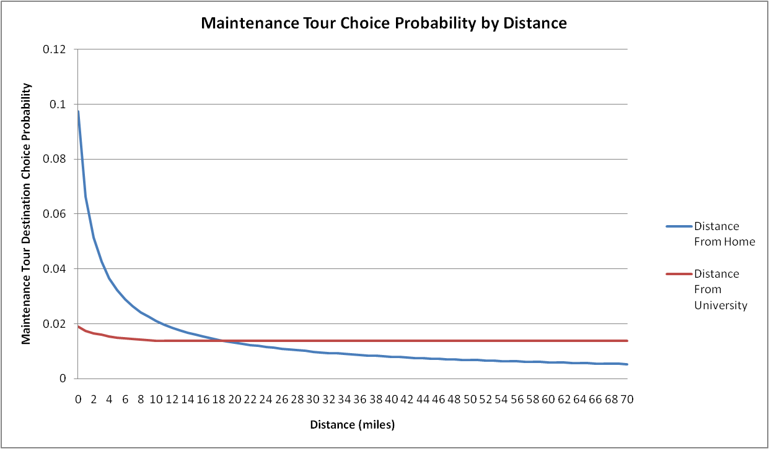

Figure 9: Maintenance Tour Destination Choice Probability Distance Decay Functions

#### Calibration Targets

Although there were multiple variables in the maintenance tour destination choice model, the calibration term chosen was the distance between the home and maintenance tour locations. The distance from home to the maintenance tour destination was the primary distance term used in the model, so the natural log of the distance from home to the maintenance tour destination was used in calibrating the model. The calibration targets for maintenance tour destination choice, calculated from the weighted survey data, are shown in Table 20.

Table 18: Maintenance Tour Location Choice Calibration Targets

|  |  |  |
| --- | --- | --- |
| **Distance from Home** | **Count** | **Share** |
| 0 | 1,213 | 32.6% |
| 1 | 872 | 23.4% |
| 2 | 476 | 12.8% |
| 3 | 425 | 11.4% |
| 4 | 319 | 8.6% |
| 5 | 117 | 3.2% |
| 6 | 222 | 6.0% |
| 7 | 0 | -- |
| 8 | 0 | -- |
| 9 | 76 | 2.0% |
| 10 | 0 | -- |
| 11 | 0 | -- |
| 12 | 0 | -- |
| 13 | 0 | -- |
| 14 | 0 | -- |
| 15 | 0 | -- |

The calibration was performed using two methods. For the tours less than 3 miles from the home location a calibration constant was asserted to match the survey shares in those categories. For maintenance tours 3 miles or more from the home location, the calibration constant was applied to the natural log of the distance (plus one for consistency with the model). This allowed for the model to more closely match the shares in the first three categories and match the functional shape for all other distances.

#### Calibration Results

The calibration constants used in the Maintenance Tour Destination Choice model are shown in Table 19. The constants for destinations less than 3 miles from home were multiplied by 1, and the constants for destinations more than 3 miles from home were multiplied by the natural log of the distance.

Table : Maintenance Tour Location Choice Calibration Constants

|  |  |  |
| --- | --- | --- |
| **Distance from Home** | **Calibration Term** | **Calibration Constant** |
| 0 – 1 miles | 1 | -0.1382 |
| 1 – 2 miles | 1 | -0.6076 |
| 2 – 3 miles | 1 | 1.2595 |
| 3 + miles | LN(Distance + 1) | 1.4996 |

The final calibration results are shown in Figure 10. Although the overall functional shape is close between the model and the survey, some categories such as tour destinations between 3 and 4 miles from home and those between 6 and 7 miles from home show noticeable differences between the survey share and the final calibrated model share. The average distance between home and the maintenance tour destination is within 0.04 miles of the average distance from the weighted survey.

The average distance between home and the maintenance tour destination in the weighted survey was 2.38 miles, and the average distance from the model output is only slightly lower at 2.34 miles. The constants added to the distance categories less than 3 miles allow the model to match the shares seen in the survey data more closely.

### Discretionary Tour Destination Choice

Figure : Maintenance Tour Destination Choice Model Calibration

The discretionary purpose destination choice model predicts the primary destination of discretionary tours. Discretionary tours include tours for recreation, visiting, eating out, and other discretionary activities.

#### Estimation Dataset

In the University of Oregon Student Travel Survey there are 135 observed discretionary tour records that were used to estimate the discretionary tour destination choice model.

#### Explanatory Variables

The following variables have been examined and proved to be significant in the utility functions:

* Mode choice logsum
* Impedance between potential discretionary locations and home
  + Natural Log of distance from home
* Impedance between potential discretionary locations and the University (represented by zone 398):
  + Squared distance from the University
* Distance interacted with person and household characteristics:
  + Year in school (Freshman/Sophomore) interacted with distance from home
  + Student status (full-time or part-time) interacted with distance from home
  + Gender interacted with distance from home
* Size Terms:
  + Retail Employment
  + Service Employment
  + Total households

Table 20 shows the frequency of distance to discretionary locations for all persons in the dataset. Over 90% of discretionary tours took place to destinations less than 6 miles from the students’ home locations. The distances from home and the university were both capped at 10 miles to account for the fact that no students in the survey traveled more than 10 miles from home or the University for a discretionary tour.

Table 20: Frequency of Distance to Chosen Discretionary Tour Destinations

|  |  |  |  |  |
| --- | --- | --- | --- | --- |
|  | Distance from Home | | Distance from the University | |
| Bin (miles) | Frequency | Cumulative Percentage | Frequency | Cumulative Percentage |
| 1 | 1,540 | 46.3% | 1,688 | 50.8% |
| 2 | 604 | 64.5% | 705 | 72.0% |
| 3 | 291 | 73.2% | 390 | 83.7% |
| 4 | 344 | 83.6% | 433 | 96.7% |
| 5 | 75 | 85.8% | 44 | 98.0% |
| 6 | 192 | 91.6% | 30 | 98.9% |
| 7 | 66 | 93.6% | 35 | 100.0% |
| 8 | 98 | 96.5% | 0 | 100.0% |
| 9 | 49 | 98.0% | 0 | 100.0% |
| 10 | 67 | 100.0% | 0 | 100.0% |
| Total | 3,325 | 100.0% | 3,325 | 100.0% |

#### Model Estimation Results

The discretionary destination choice results are summarized in Table 21.

Table 21: Discretionary Tour Destination Choice Model Estimation Results

**Observations:** 129

**Final log likelihood: -**672

**Rho-Squared (0):** 0.1990

|  |  |  |
| --- | --- | --- |
| **Utility Function Variables** | **Coeff** | **T-Stat** |
| Mode Choice Logsums | 0.669 | 2.40 |
| Distance from Home Natural Log | -1.952 | -3.40 |
| Distance from University Squared | -0.074 | -3.65 |
| *Year in School* |  |  |
| Freshman/Sophomore*Distance from Home | -0.190 | -0.95 |
| *Student Type* |  |  |
| Full-time Student*Distance from Home | -0.264 | -0.87 |
| *Gender* |  |  |
| Male*Distance from Home | 0.428 | 2.83 |
| *Size Function* |  |  |
| Service Employment | 1.000 |  |
| Retail Employment | 0.362 | -1.01 |
| Total Households | 0.230 | -4.24 |

#### Model Estimation Findings

* The logsum variable indicates the importance of accessibility of potential discretionary tour locations from the home. The coefficient on mode choice logsum is positive and between 0 and 1, as expected.
* The distance variable shows the importance of distance from home and the University in a student’s choice of discretionary tour location. Although other linear and nonlinear formulations of the distance terms were tested, only the natural log for the distance from home and the distance squared for the distance from the University provided a decreasing functional relationship between the choice probability and the distance, as shown in Figure 11.
* The Freshman and Sophomore variable shows the impact of distance on the discretionary tour destination choice specifically for Freshman and Sophomore students. The negative coefficient indicates that younger students tend to find discretionary activities closer to home than older students.
* The variable for full-time students interacted with distance indicates whether full-time students assign a different importance to distance than part-time students when choosing a discretionary tour destination. The negative coefficient shows that students attending school full-time tend to choose discretionary activities closer to home than students who attend school part-time.
* The gender variable indicates whether male students or female students are more sensitive to the distance in choosing a discretionary tour location. The positive coefficient demonstrates that male students are less sensitive to the distance of the tour destination from home than female students.
* Size term effects:
  + Service Employment was used as the base employment category. Retail Employment and Total Households were also included in the size term as discretionary tour purposes include eating out and social visits.
  + Retail Employment has a slightly greater impact on the choice of a discretionary tour destination than the number of households, but both had less than half of the impact of Service Employment.

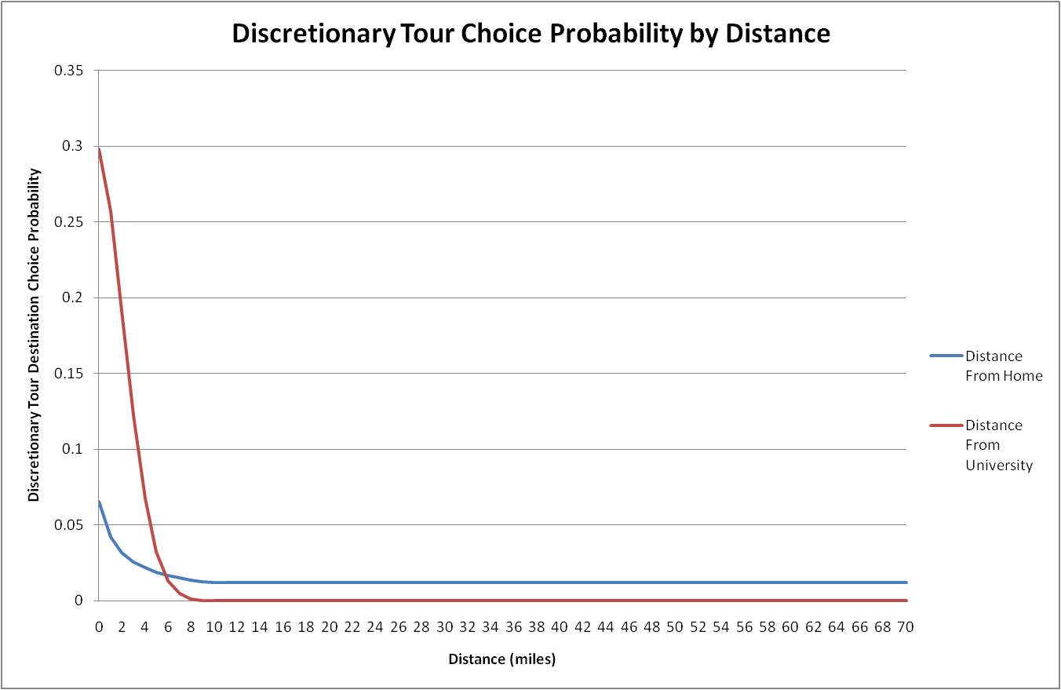

Figure 11: Discretionary Tour Destination Choice Probability Distance Decay Functions

#### Calibration Targets

Although there were multiple variables in the discretionary tour destination choice model, the calibration term chosen was the distance between the home and discretionary tour locations. The distance from home to the discretionary tour destination was the primary distance term used in the model, so the natural log of the distance from home to the discretionary tour destination was used in calibrating the model. The calibration targets for discretionary tour destination choice, calculated from the weighted survey data, are shown in Table 22.

Table 22: Discretionary Tour Location Choice Calibration Targets

|  |  |  |
| --- | --- | --- |
| **Distance from Home** | **Count** | **Share** |
| 0 | 1,540 | 46.3% |
| 1 | 604 | 18.2% |
| 2 | 291 | 8.8% |
| 3 | 344 | 10.3% |
| 4 | 75 | 2.2% |
| 5 | 192 | 5.8% |
| 6 | 66 | 2.0% |
| 7 | 98 | 2.9% |
| 8 | 49 | 1.5% |
| 9 | 67 | 2.0% |
| 10 | 0 | -- |
| 11 | 0 | -- |
| 12 | 0 | -- |
| 13 | 0 | -- |
| 14 | 0 | -- |
| 15 | 0 | -- |

The calibration was performed using two methods. For the tours less than 2 miles from the home location a calibration constant was asserted to match the survey shares in those categories. For discretionary tours 2 miles or more from the home location, the calibration constant was applied to the natural log of the distance (plus one for consistency with the model). This allowed for the model to more closely match the shares in the first two categories and match the functional shape for all other distances.

#### Calibration Results

Table 23 shows the calibration constants calculated for the Discretionary Tour Destination Choice Model. The constants for destinations less than 2 miles from home were multiplied by 1, and the constants for destinations more than 2 miles from home were multiplied by the natural log of the distance.

Table : Discretionary Tour Location Choice Calibration Constants

|  |  |  |
| --- | --- | --- |
| **Distance from Home** | **Calibration Term** | **Calibration Constant** |
| 0 – 1 miles | 1 | 0.4744 |
| 1 – 2 miles | 1 | 0.3752 |
| 2 + miles | LN(Distance + 1) | 1.1288 |

The final calibration results are shown in Figure 12. In many of the distance categories greater than 2 miles this model showed larger differences between the survey and the model results than the other destination choice models after calibration. Overall, though, the average distance between home and the discretionary tour destination is within 0.01 miles of the average distance from the weighted survey, and the overall functional shape is similar between the model and the survey.

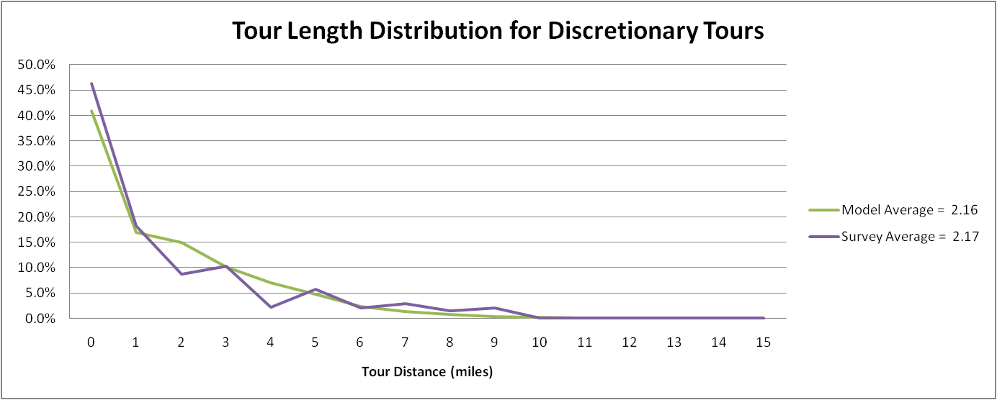The average distance between home and the discretionary tour destination in the weighted survey was 2.17 miles, and the average distance from the model output is nearly identical at 2.16 miles. Both distances are also similar to the average maintenance tour distance. This similarity is likely because both types of tours are non-mandatory and have similar factors affecting the choice of location.

Figure : Discretionary Tour Destination Choice Model Calibration

# Tour Time-of-Day Choice

Tour time-of-day choice is performed by simulating from observed probability distributions by tour purpose. The observed distributions are in half-hour periods and are multi-dimensional – including both the outbound period (period leaving home) and the inbound period (period returning home). The distributions are shown Figure 13 through Figure 16. Note that in the tour-based model, each tour is independent of every other tour; therefore it is possible that tours made by the same person could overlap time periods.

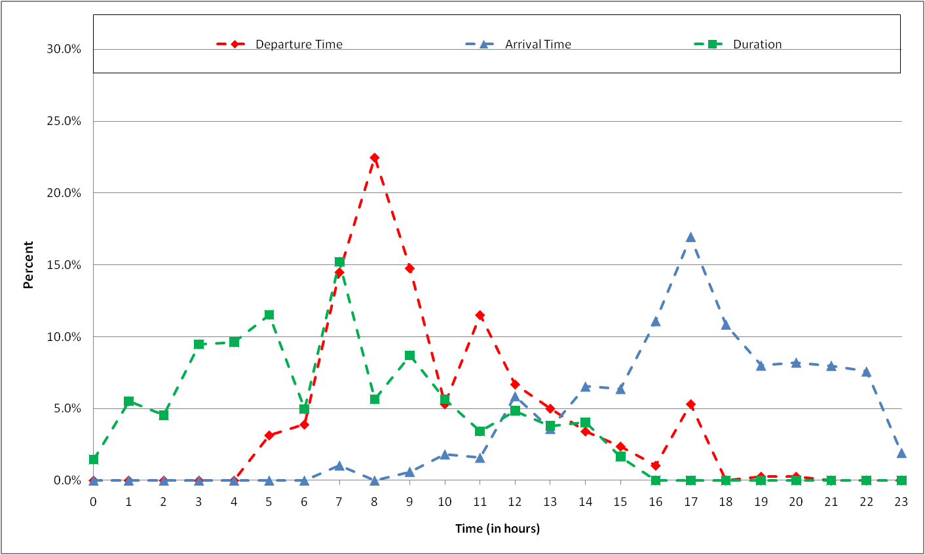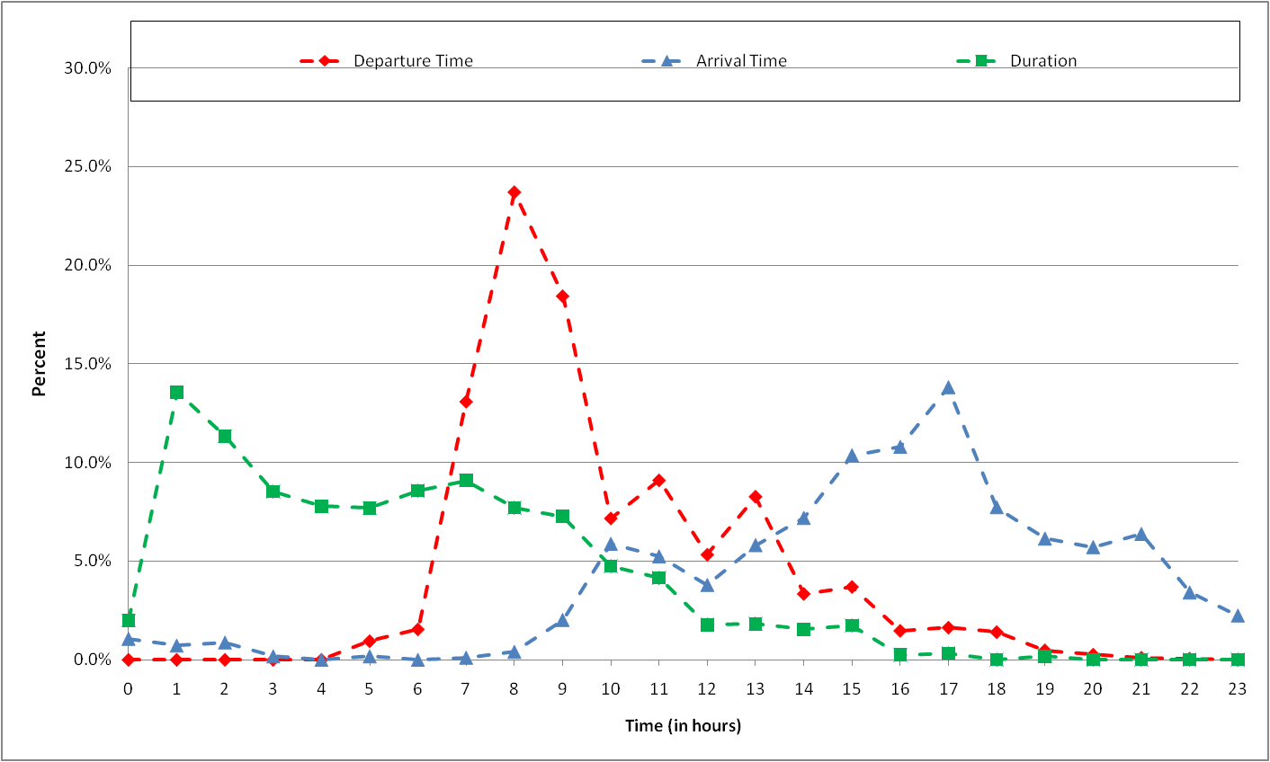

Figure : Work Tour Departure, Arrival, and Duration Time Distribution

Figure : University Tour Departure, Arrival, and Duration Time Distribution

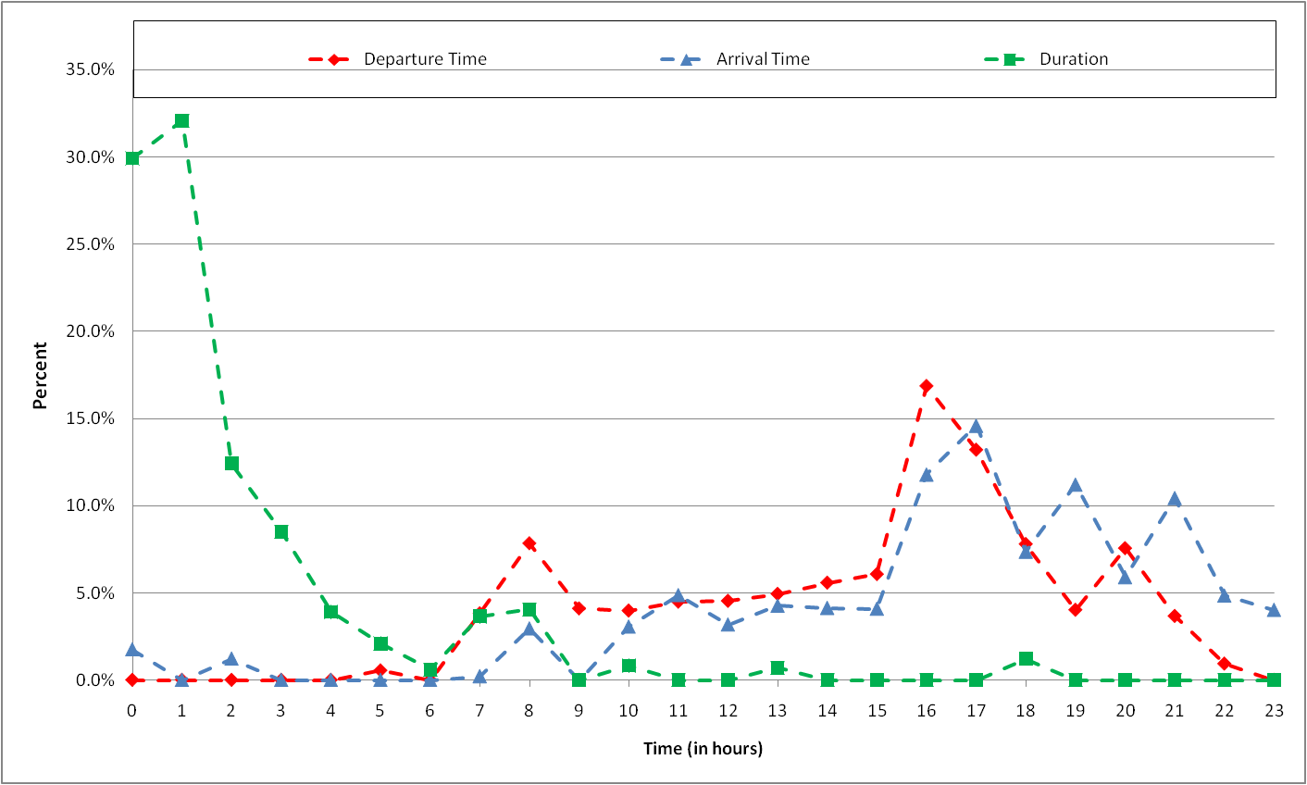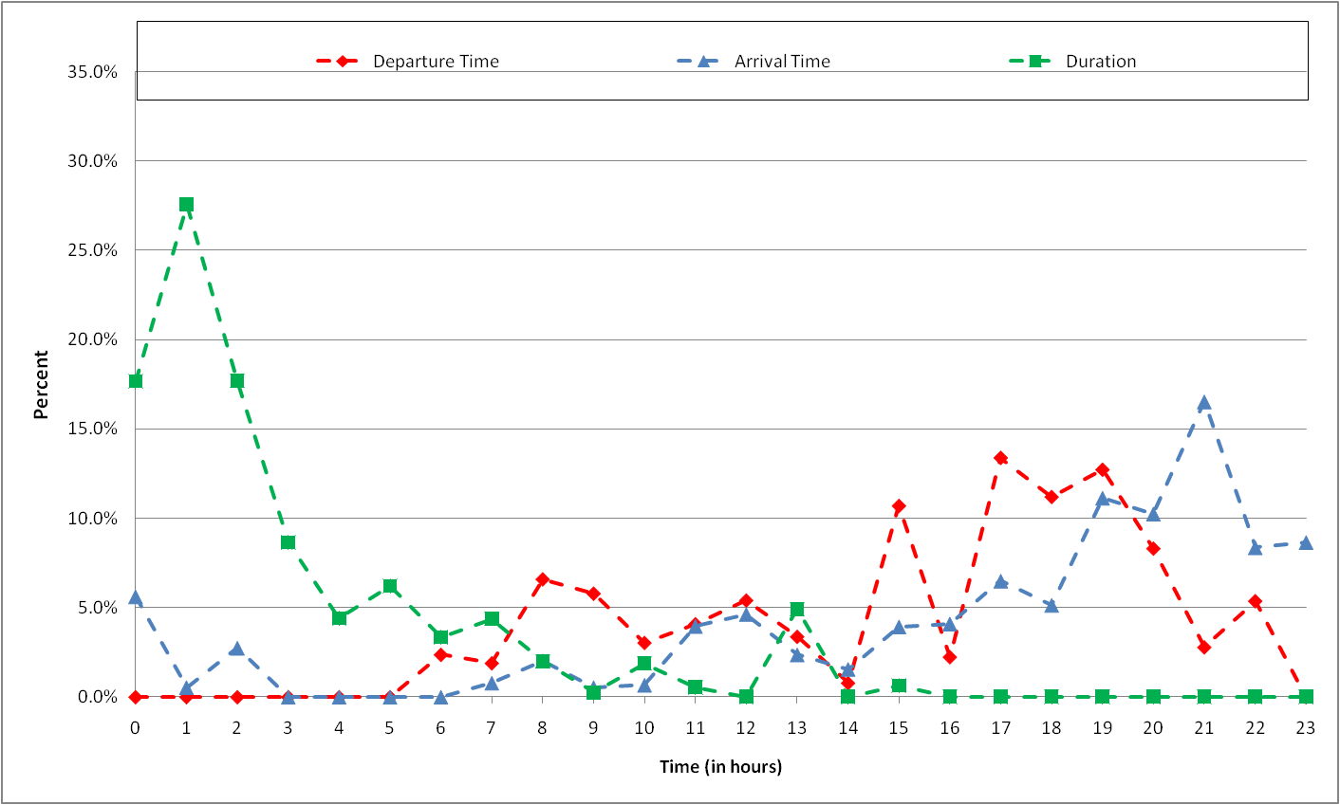

Figure : Maintenance Tour Departure, Arrival, and Duration Time Distribution

Figure : Discretionary Tour Departure, Arrival, and Duration Time Distribution

# Tour Mode Choice Model

The tour mode choice model selects a mode to use for each tour based on the cost and time associated with each mode as well as other tour and person characteristics. The mode for any trips within the tour is calculated separately and takes into account the tour mode.

### Estimation Dataset

The tour mode choice model was used to match the mode shares for work, university, maintenance, and discretionary tour purposes. The modes from the survey were combined in most cases in order to ensure that there were a sufficient number of observations in each mode. The model was estimated for all cases, but the calibration was performed and applied separately by auto ownership level. The number of observations of each mode by auto ownership for each tour purpose from the weighted survey is included in Table 24.

Table 24: Tour Mode Choice Observations by Tour Purpose and Auto Ownership

|  |  |  |  |  |  |  |  |  |  |
| --- | --- | --- | --- | --- | --- | --- | --- | --- | --- |
| **Tour Mode** | **University** | | **Work** | | **Maintenance** | | **Discretionary** | | |
| **No Auto** | **Auto** | **No Auto** | **Auto** | **No Auto** | **Auto** | **No Auto** | **Auto** |
| Drive Alone | 21 | 2,097 | 0 | 635 | 8 | 830 | 49 | 372 |
| HOV2 | 247 | 2,039 | 35 | 283 | 133 | 1,313 | 308 | 688 |
| HOV3+ | 22 | 110 | 0 | 0 | 0 | 165 | 22 | 66 |
| Walk | 2,680 | 4,598 | 327 | 362 | 181 | 432 | 693 | 637 |
| Bike | 1,265 | 2,607 | 375 | 554 | 133 | 234 | 65 | 147 |
| Walk/Bike to Transit | 1,300 | 2,526 | 71 | 319 | 161 | 130 | 177 | 51 |
| PNR | 0 | 219 | 0 | 0 | 0 | 0 | 0 | 0 |
| KNR | 68 | 0 | 0 | 0 | 0 | 0 | 75 | 0 |

The model also used cost and travel time skims from the existing LCOG model of the Eugene region. These skims provided expected costs, wait times, transfer times, and in-vehicle times for each mode. The transit modes required additional processing due to the mode hierarchy used in assigning a tour mode to the survey data. If a tour was made by transit, it was assigned a premium transit tour mode if any trip along the tour used premium transit. Unfortunately, there were over 50 survey records that listed premium transit as the tour mode but only had local transit available between the origin and destination zones in the skims. In order to account for this, a set of combined “general transit” mode skims was developed and used in the model estimation. These skims used premium transit travel times and costs where available and local transit values for all other zones. An additional variable was then added to calculate the estimated impact of having premium transit available between the origin and destination zones.

### Model Formulation and Explanatory Variables

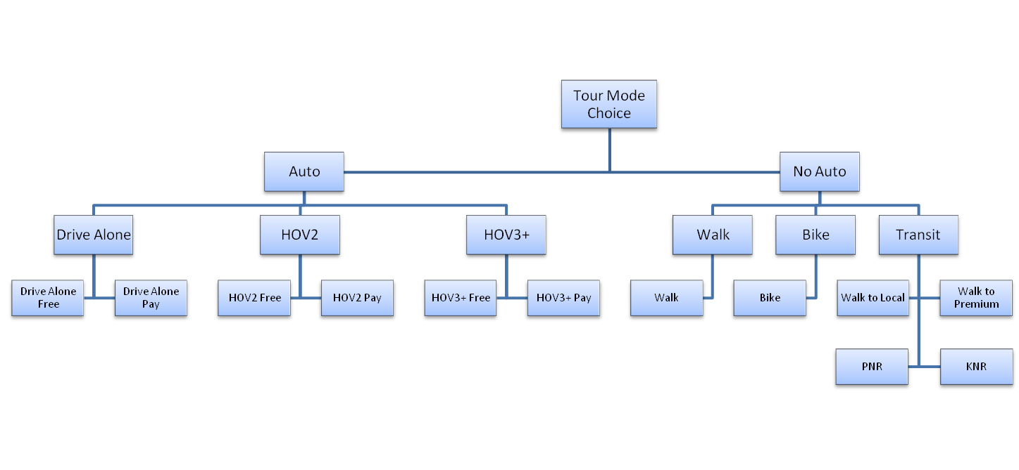The tour mode choice model was estimated and applied using a three-level nesting structure. The first level splits the auto and non-auto modes. The second level splits the auto modes into drive alone, shared ride 2, and shared ride 3+, and it splits the non-auto modes into walk, bike and transit. The third level split the auto modes into free and pay for each mode, and it further disaggregates the transit mode into walk/bike to local, walk/bike to premium transit, park-and-ride, and kiss-and-ride. This nesting structure is shown in Figure 17.

Figure : Tour Mode Choice Nesting Structure

In the model estimation, however, only drive alone, shared ride 2, shared ride 3+, walk, bike, and walk/bike to transit were observed. Walk was used as the base mode in model estimation since it had the most observations, and constants were calculated for all other modes.

The following variables have been examined and proved to be significant in the utility function for auto modes:

* In-vehicle travel time
* Operating cost (Distance * Average Cost Per Mile)
* Parking cost
* Transfer time
* Time to pick up other passengers (for shared ride modes)
* University tour purpose-specific constant

The following variables have been examined and proved to be significant in the utility function for the bike and walk modes:

* Mode-specific travel time

The following variables have been examined and proved to be significant in the utility function for the walk and bike to transit modes:

* In-vehicle travel time
* Transfer time
* Walk-access time
* Constant for premium transit availability
* University tour purpose-specific constant
* No-auto constant

Cost was not included as a variable in the transit mode estimation because University of Oregon students and staff can use transit modes for free by showing their university ID card.

### Model Estimation Results

The tour mode choice results are summarized in Table 25. The values shown are before any nesting coefficients are applied, so they must be adjusted for model application.

Table 25: Tour Mode Choice Estimation Results

**Observations:** 1,082

**Final log likelihood: -**1,293

**Rho-Squared (0):** 0.2936

|  |  |  |
| --- | --- | --- |
| **Utility Function Variables** | **Coeff** | **T-Stat** |
| Nesting Coefficient | 0.537 | 7.75 |
| *Mode-specific Constants* |  |  |
| Drive Alone | -1.622 | -3.34 |
| Shared Ride 2 | -1.447 | -3.05 |
| Shared Ride 3+ | -4.038 | -7.12 |
| Bike | -2.845 | -13.65 |
| Walk/Bike to Transit | -4.611 | -11.11 |
| Premium Transit Available | 0.247 | 1.90 |
| *Travel Time and Cost* |  |  |
| In-vehicle Travel Time (in minutes) | -0.079 | -4.06 |
| Out-of-vehicle Travel Time (Transfer and Wait)* | -0.118 |  |
| Walk Time | -0.123 | -12.53 |
| Bike Time | -0.112 | -6.21 |
| Travel Cost (in cents) | -0.009 | -4.88 |
| *University Tour Purpose Constants* |  |  |
| Drive Alone | -0.736 | -1.86 |
| Shared Ride 2 | -1.096 | -2.86 |
| Shared Ride 3+ | -1.361 | -2.15 |
| Walk/Bike to Transit | 0.625 | 2.38 |
| *No Auto Constants* |  |  |
| Shared Ride 2 | -2.591 | -4.02 |
| Shared Ride 3+ | -2.616 | -2.70 |
| Transit | 0.645 | 2.67 |

*Note: The out-of-vehicle time coefficient was fixed at 1.5 times the in-vehicle travel time coefficient because it could not be estimated accurately on its own.

### Model Estimation Findings

* The nesting coefficient indicates the relative importance of the first and second levels of nesting in the tour mode choice. A nesting coefficient of 0.5 indicates that cross-elasticities are approximately twice as high across nested alternatives as between non-nested alternatives.
* The premium transit mode constant indicates that having premium transit available is worth approximately 3 minutes of in-vehicle travel time in choosing between local and premium transit modes.
* The coefficients on in-vehicle time and travel cost indicate that the value of time is approximately $5.25 per hour.
* The walk and bike time coefficients are more negative than the coefficient on motorized in-vehicle time, as expected. The coefficient on walk time is more negative than the bike time coefficient, indicating that time spent walking is more onerous than the same amount of time spent on a bike.
* The university and no auto constants show that students traveling for university tours and those without an auto available are more likely to use transit than other modes.

### Calibration Targets

The model calibration was performed to match the mode shares by tour purpose and auto ownership, and the targets are shown in Table 26. The calibration was performed by adjusting the relative changes with the HOV 2 mode as the base for no-auto students and Drive Alone as the base for students with an auto available. The constants were applied by filtering for the tour mode and auto ownership, and the base constant was set to zero. Any modes that were not possible or observed were given a constant of -999 in the utility calculation to ensure that they could not be chosen in the model application.

Table 26: Tour Mode Choice Calibration Targets

|  |  |  |  |  |  |  |  |  |  |
| --- | --- | --- | --- | --- | --- | --- | --- | --- | --- |
| **Tour Mode** | **University** | | **Work** | | **Maintenance** | | **Discretionary** | | |
| **No Auto** | **Auto** | **No Auto** | **Auto** | **No Auto** | **Auto** | **No Auto** | **Auto** |
| Drive Alone | 0.4% | 14.8% | -- | 29.5% | 1.3% | 26.7% | 3.5% | 18.9% |
| HOV2 | 4.4% | 14.4% | 4.3% | 13.2% | 21.6% | 42.3% | 22.1% | 35.1% |
| HOV3+ | 0.4% | 0.8% | -- | -- | -- | 5.3% | 1.6% | 3.4% |
| Walk | 47.8% | 32.4% | 40.4% | 16.8% | 29.4% | 13.9% | 49.9% | 32.5% |
| Bike | 22.6% | 18.4% | 46.5% | 25.7% | 21.6% | 7.6% | 4.7% | 7.5% |
| Walk/Bike to Transit | 23.2% | 17.8% | 8.8% | 14.8% | 26.1% | 4.2% | 12.8% | 2.6% |
| PNR | -- | 1.5% | -- | -- | -- | -- | -- | -- |
| KNR | 1.2% | -- | -- | -- | -- | -- | 5.4% | -- |

The non-mandatory tours showed a higher share for shared ride modes than the mandatory tours. The share of walk and bike tours were much lower for students with an auto available than those with no auto across all tour purposes. Table 27 also shows the number of tours by mode in each tour purpose and auto ownership category from the survey. These were the controls used to develop the calibration targets.

Table : Tour Mode Choice Calibration Controls

|  |  |  |  |  |  |  |  |  |  |
| --- | --- | --- | --- | --- | --- | --- | --- | --- | --- |
| **Tour Mode** | **University** | | **Work** | | **Maintenance** | | **Discretionary** | | |
| **No Auto** | **Auto** | **No Auto** | **Auto** | **No Auto** | **Auto** | **No Auto** | **Auto** |
| Drive Alone | -- | 2,117 | -- | 635 | -- | 838 | -- | 420 |
| HOV2 | 247 | 2,039 | 35 | 283 | 133 | 1,313 | 308 | 688 |
| HOV3+ | 22 | 110 | -- | -- | -- | 165 | 22 | 66 |
| Walk | 2,680 | 4,598 | 327 | 362 | 181 | 432 | 693 | 637 |
| Bike | 1,265 | 2,607 | 375 | 554 | 133 | 234 | 65 | 147 |
| Walk/Bike to Transit | 1,300 | 2,526 | 71 | 319 | 161 | 130 | 177 | 51 |
| PNR | -- | 219 | -- | -- | -- | -- | -- | -- |
| KNR | 68 | -- | -- | -- | -- | -- | 75 | -- |
| **Total** | **5,583** | **14,215** | **807** | **2,153** | **608** | **3,112** | **1,340** | **2,010** |

### Calibration Results

The calibration constants used in the final model application are shown in Table 28. The largest constants were in the non-auto modes, especially transit which had higher shares in the survey than would be expected based on the original model application.

Table : Tour Mode Choice Calibration Constants

|  |  |  |  |  |  |  |  |  |  |
| --- | --- | --- | --- | --- | --- | --- | --- | --- | --- |
| **Tour Mode** | **University** | | **Work** | | **Maintenance** | | **Discretionary** | | |
| **No Auto** | **Auto** | **No Auto** | **Auto** | **No Auto** | **Auto** | **No Auto** | **Auto** |
| Drive Alone | 0 | 0 | 0 | 0 | 0 | 0 | 0 | 0 |
| HOV2 | 0 | 0.207 | 0 | -0.370 | 0 | 0.424 | 0 | 0.441 |
| HOV3+ | 0.655 | 0.530 | 0.724 | -0.786 | -0.313 | 0.913 | 0.346 | 0.853 |
| Walk | -0.341 | 0.104 | 1.557 | 0.160 | -0.176 | -0.450 | 0.0280 | 0.743 |
| Bike | -0.564 | -0.565 | 1.507 | 0.195 | -0.409 | -0.705 | -1.283 | -0.295 |
| Walk/Bike to Transit | 1.393 | 1.856 | 2.648 | 2.489 | 2.211 | 1.670 | 1.603 | 1.788 |
| PNR | -0.719 | 3.193 | 0.724 | -0.786 | -0.313 | -0.467 | 0.147 | -0.478 |
| KNR | 2.213 | -0.574 | 0.724 | -0.786 | -0.313 | -0.467 | 3.436 | -0.478 |

The results of the trip mode choice calibration are shown in Table 29 and Table 30 below. Table 29 shows the absolute difference in the number of students using each mode for each tour purpose and auto ownership level. Table 30 shows the absolute difference in the share of students selecting each mode by tour purpose and auto ownership. The mode shares at the end of the model calibration process were all within 2% of the target shares.

It is important to note that the total number of tours in each auto ownership category is not exactly equal between the model and the survey. Therefore, the difference in the mode choice shares provides a more accurate comparison than the number of students. The Totals row indicates the differences in tour generation levels by auto ownership category. Auto ownership was not used as a control in the tour generation model, so the rates within each category do not match the survey as well as the totals. Adding an auto ownership control to the tour generation model could allow the model to more closely match the number of tours using each mode by both tour purpose and auto ownership. With the current implementation, students with no car available tend to generate too many University and Maintenance tours and too few Work and Discretionary tours when compared to the calibration controls.

Table : Tour Mode Choice Calibration Results – Absolute Difference in Student Totals

|  |  |  |  |  |  |  |  |  |  |
| --- | --- | --- | --- | --- | --- | --- | --- | --- | --- |
| **Tour Mode** | **University** | | **Work** | | **Maintenance** | | **Discretionary** | | |
| **No Auto** | **Auto** | **No Auto** | **Auto** | **No Auto** | **Auto** | **No Auto** | **Auto** |
| Drive Alone | -- | -134 | -- | 44 | -- | -147 | -- | 17 |
| HOV2 | 16 | -161 | -6 | 0 | 92 | -201 | -99 | 106 |
| HOV3+ | 12 | 34 | 1 | 3 | 2 | -28 | -2 | 12 |
| Walk | 384 | -286 | -78 | 2 | 133 | -61 | -184 | 101 |
| Bike | 166 | -192 | -80 | 9 | 81 | -26 | -11 | 22 |
| Walk/Bike to Transit | 140 | -204 | -20 | 16 | 99 | -27 | -54 | 14 |
| PNR | -- | 31 | -- | -- | -- | -- | -- | -- |
| KNR | 6 | -- | -- | -- | -- | -- | -23 | -- |
| **Totals** | **723** | **-911** | **-182** | **74** | **407** | **-490** | **-373** | **271** |

Table 30: Tour Mode Choice Calibration Results – Absolute Difference in Shares

|  |  |  |  |  |  |  |  |  |  |
| --- | --- | --- | --- | --- | --- | --- | --- | --- | --- |
| **Tour Mode** | **University** | | **Work** | | **Maintenance** | | **Discretionary** | | |
| **No Auto** | **Auto** | **No Auto** | **Auto** | **No Auto** | **Auto** | **No Auto** | **Auto** |
| Drive Alone | -- | 0.0% | -- | 1.0% | -- | -0.6% | -- | -1.7% |
| HOV2 | -0.3% | -0.2% | 0.3% | -0.5% | 0.3% | 0.2% | -1.3% | 0.6% |
| HOV3+ | 0.1% | 0.3% | 0.0% | 0.0% | 0.0% | -0.1% | 0.4% | 0.1% |
| Walk | 0.6% | 0.1% | -0.6% | -0.5% | 1.2% | 0.3% | 1.0% | 0.7% |
| Bike | 0.0% | -0.2% | 0.7% | -0.4% | -0.8% | 0.4% | 0.7% | 0.1% |
| Walk/Bike to Transit | -0.5% | -0.3% | -0.7% | 0.2% | -0.8% | -0.2% | -0.5% | 0.3% |
| PNR | -- | 0.3% | -- | -- | -- | -- | -- | -- |
| KNR | 0.0% | -- | -- | -- | -- | -- | -0.2% | -- |

The largest differences in the mode shares were for the walk mode for non-mandatory tour purposes. The model slightly over-estimates the share of walk tours, but the differences are still less than 2% for any tour purpose.

# Stop Level Models

The intermediate stop location choice model was estimated using the university student survey data and is described below.

## Intermediate Stop Frequency Model

The frequency or number of intermediate stops is simulated by choosing a stop frequency from an observed probability distribution. The distribution of stop frequency is segmented by tour purpose (Work, University, Maintenance, Discretionary), and duration in hours (0-2, 2-4, 4-8, 8-12, 12-24). The model predicts the number of stops in each direction on the tour (outbound and inbound). Table 31 shows the frequency of each stop pattern (the number of inbound and outbound stops) by tour purpose. All purposes were most likely to have either no stops in either direction or only inbound stops.

Table : Stop Pattern Frequency by Tour Purpose

|  |  |  |  |  |
| --- | --- | --- | --- | --- |
| **Stop Pattern** | **Work** | **University** | **Maintenance** | **Discretionary** |
| 0 Out, 0 In | 47% | 44% | 49% | 70% |
| 0 Out, 1 In | 16% | 22% | 18% | 12% |
| 0 Out, 2 In | 3% | 13% | 6% | 5% |
| 0 Out, 3 In | 15% | 10% | 6% | 3% |
| 1 Out, 0 In | 8% | 3% | 9% | 6% |
| 1 Out, 1 In | 1% | 2% | 3% | 3% |
| 1 Out, 2 In | 3% | 1% | 1% | -- |
| 1 Out, 3 In | 1% | 2% | 2% | 0% |
| 2 Out, 0 In | 3% | 1% | 4% | 1% |
| 2 Out, 1 In | 2% | -- | 0% | -- |
| 2 Out, 2 In | -- | -- | 1% | -- |
| 2 Out, 3 In | -- | 1% | -- | -- |
| 3 Out, 0 In | 1% | 0% | -- | -- |
| 3 Out, 1 In | 0% | -- | -- | -- |
| 3 Out, 2 In | -- | 0% | -- | -- |
| 3 Out, 3 In | -- | 0% | -- | -- |

The total number of stops for each tour purpose is illustrated in Figure 18. While Discretionary tours are much more likely than other purposes to make no stops, work tours are the most likely to make three or more stops.

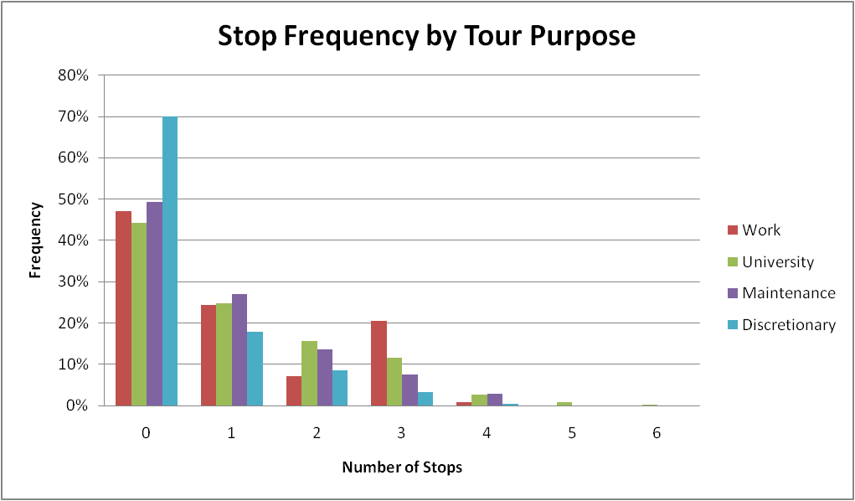

Figure : Stop Frequency by Tour Purpose

## Intermediate Stop Purpose Model

The purpose of each stop is simulated from observed probability distribution which is segmented by tour purpose (Work, University, Maintenance, or Discretionary), the direction of travel (outbound versus inbound), the number of stops on the journey (1, 2, 3, or 4) and whether the stop is the only stop on the journey or one of multiple stops. Figure 19 through Figure 22 show the number of stops by tour purpose for each stop purpose. There are very few work and university stops for all tour purposes, most likely because these are the primary tour purposes. There are many more maintenance and discretionary stops for all tour purposes.

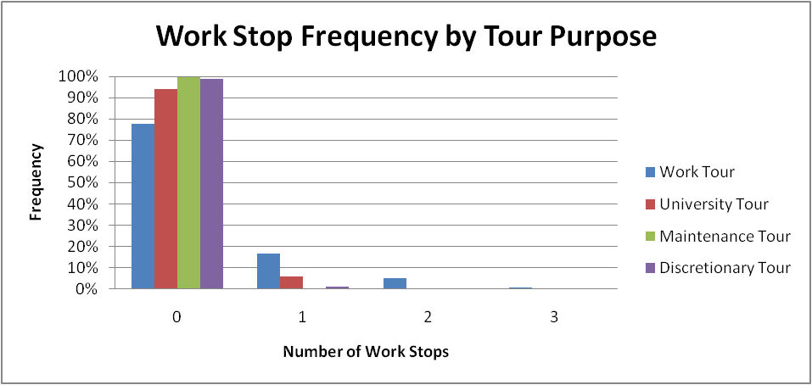

Figure : Work Stop Frequency Distribution

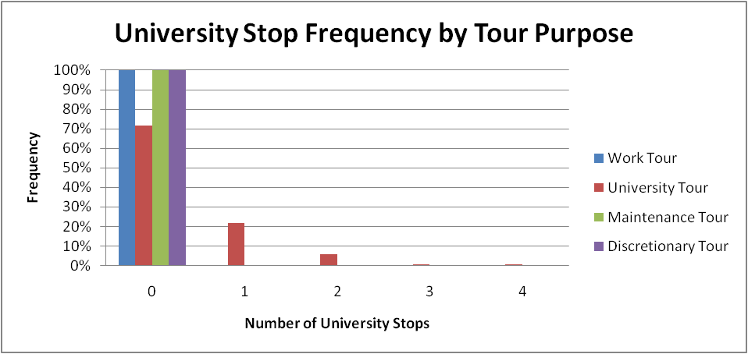

Figure : University Stop Frequency Distribution

## 

Figure : Maintenance Stop Frequency Distribution

Figure : Discretionary Stop Frequency Distribution

## Intermediate Stop Location Choice Model

The intermediate stop location choice model predicts the location (TAZ) of each intermediate stop (each location other than the origin and primary destination) on the tour. In this model, a maximum of 4 stops in outbound and 4 stops in inbound direction are modeled for each tour. A number of variables were tested in the stop location choice models, including mode choice logsum, travel distance deviation for stop from the half-tour path, ratio of the distance deviation to the direct distance, distance from the stop to the origin, distance from the stop to the destination, and the size terms from the tour destination choice models. The models were estimated in ALOGIT software as a multinomial logit model.

### Estimation Dataset

The estimation dataset included 698 observed stop records for non-University stops including up to 4 stops in each direction. University stops were not included in this model as their stop location choice is related more to class schedules and campus buildings than the factors that affect stop choices for other purposes. Table 32 below shows the number and percentage of stop records by stop purpose. Most of the stops are made for eating out, maintenance and shopping activities comprising for more than 70% of all stops. There are a nearly equal share of tours made for maintenance purposes (Escorting, Shopping, and Maintenance) and discretionary purposes (Eating Out, Social Visits, and Discretionary).

Table : Number of Stop Records by Stop Purpose

|  |  |  |
| --- | --- | --- |
| Stop Purpose | # of Stops by Activity Purpose | Share of Stops by Activity Purpose |
| Work | 63 | 9% |
| Escorting | 37 | 5% |
| Shopping | 114 | 16% |
| Maintenance | 160 | 23% |
| Eating out | 182 | 10% |
| Visiting | 72 | 26% |
| Discretionary | 70 | 10% |
| Total | 698 | 100% |

### Model Utility

The utility () of choosing a stop TAZ(*s*) for an individual (*n*) for stop purpose (k) between the previous location TAZ (*i*) and half-tour destination TAZ (j) is given by Equation 3.

Equation 3



Where:

 = the size function for stop TAZ (s) and stop purpose (k)

 = sum of the logsum from the tour origin to the stop location and the logusm from the tour destination to the stop location.

 = the various distance deviation terms (*p = linear, log, square root, squared, and cubed*) for stop *(s).*

 = the relative distance deviation

The size function () for stop location s, purpose k is a the size variable estimated in the tour destination choice model for tour purpose k. It is included in the utility function as a log term.

### Explanatory Variables

It is not straightforward to segment the model by purpose because size (or attraction) variables are related to purpose of the stop activity while impedance variables are strongly related to the tour characteristics – primary tour purpose, primary mode used for the tour, etc. Therefore, a single model is estimated with size variables based on stop purpose and utility variables based on tour characteristics.

The following variables have been examined and proved to be significant in the utility functions:

1. Mode choice logsum
2. Distance deviation or “out-of-the-way” distance for stop location when compared to the half-tour distance without detour for any stop
3. Distance Deviation Natural Log
4. Size variables
5. Size term from tour-destination choice models for the tour purpose

The model operates at a half-tour level using distance and level-of-service to get from half-tour origin to half-tour destination via stop location. In case of multiple stops on a half-tour, the stop locations are processed in a chronological order. The first stop is considered as the origin zone for the second stop, and second is considered the origin zone for the third stop. Detailed processing of stops is explained below.

### Processing of Stops

The example below explain show the stops are processed and how the distance deviation is calculated. Consider a tour from home (i) to primary tour destination (j) with distance *Dij* between the two locations. Assume that this tour has two stops on the outbound half-tour and one stop on the inbound half-tour. The process described below applies to additional stops in any direction.

Home)

Primary tour Destination

*Dij*

First, process the first outbound stop (k) for the half-tour. The absolute distance deviation (*dk*) for stop k is given by and relative distance deviation (Rk) is given by

,

where *Dik* is the distance from home (i) to stop k and *Dkj* is the distance from stop k to primary destination (j).

*Dij*

*Dik*

*Dkj*

Home

Primary tour Destination

Let’s consider the second stop (m) on the half-tour. Since the location of stop (k) is already decided, the deviation for next stop is calculated based on stop (k) as the origin.

The absolute distance deviation (*dm*) for stop m is given by:

The relative distance deviation (*Rm*) is given by:

where *Dkm* is the distance from stop k to stop m, and *Dmj* is the distance from stop m to primary destination (j).

*Dkj*

*Dmj*

*Dkm*

Home

Primary tour Destination

Multiple stops are processed along the half-tour using the same process. For inbound half-tour, the processing is carried out in the same way except that the primary tour destination (or previous stop on inbound half-tour) becomes origin location and home becomes destination location. The absolute distance deviation (*dp*) for stop p on the inbound half-tour is given by:

And the relative distance deviation (*Rp*) for stop p on the inbound half-tour is given by:

where *Djp* is the distance from primary destination (j) to stop p and *Dpi* is the distance from stop p to home (i).

*Dij*

*Djp*

*Dpi*

Home

Primary tour Destination

### Model Estimation Results

Table 33 shows the estimation results for the intermediate stop destination choice model. The total number of observations is 698.

Table 33: Intermediate Stop Destination Choice Model (Impedance Variables)

Number of Observations 698

Likelihood with Constants only -3874

Final likelihood -3082

ρ² w.r.t. zero 0.2814

|  |  |  |
| --- | --- | --- |
| **Utility Function Variables** | **Coeff** | **T-Stat** |
| Mode Choice Logsums | 0.632 | 13.93 |
| *Distance Deviation* |  |  |
| Distance Deviation Natural Log | -0.970 | -10.04 |
| *Size Function* |  |  |
| Tour Purpose-Specific Size Terms | 1.000 |  |

### Model Estimation Findings

* The logsum indicates the importance of the accessibility between the origin, destination, and intermediate stops. The coefficient is between 0 and 1 as expected, and it is very statistically significant, with a t-statistic of nearly 14.
* The distance deviation variable shows the sensitivity to the extra distance added (from origin to destination) by making the stop. The negative coefficient on the natural log of the distance deviation indicates that as the distance deviation increases the probability of choosing that stop location decreases. The relationship between the stop location choice probability and the deviation distance is shown in Figure 23.
* Size term effects:
  + The size terms were all fixed to match the values in the tour destination choice models for the tour purpose.

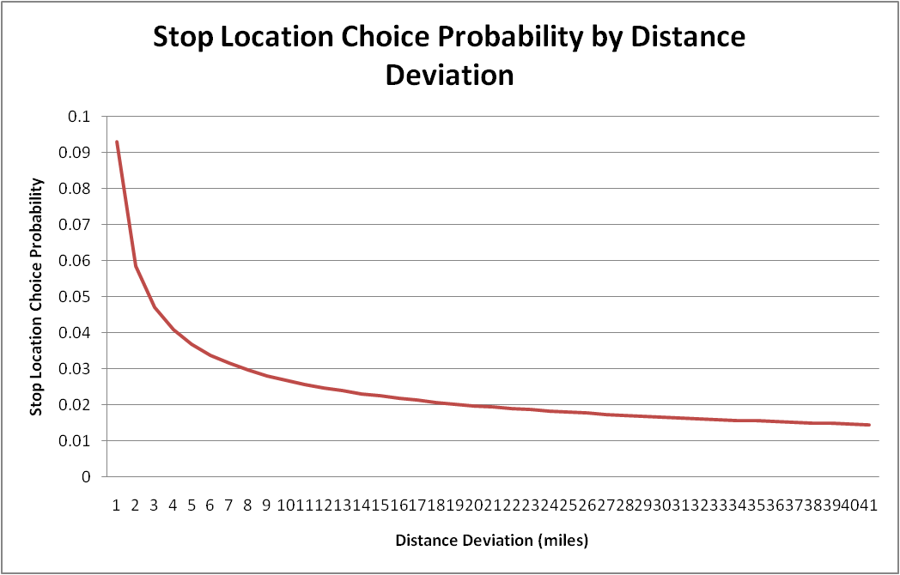

Figure : Stop Location Choice Deviation Distance Decay Function

### Calibration Targets

While the stop location choice model was estimated for all tour purposes combined, the calibration was performed separately by tour purpose. The Work, University, Maintenance and Discretionary tours each showed a unique distribution of stops by out-of-direction distance. The mandatory tours had more stops between 0 and 1 miles out-of-direction than the non-mandatory tours, and the discretionary tours had an unusually high share of negative out-of-direction distance stops. Table 34 shows the distribution of stops by out-of-direction distance for each tour purpose from the weighted survey data.

Table 34: Out of Direction Distance Trip Frequency by Tour Purpose

|  |  |  |  |  |
| --- | --- | --- | --- | --- |
| **Out-Of-Direction Distance** | **Work** | **University** | **Maintenance** | **Discretionary** |
| -1 | 4.8% | 3.2% | 0.3% | 11.5% |
| 0 | 69.4% | 69.2% | 51.2% | 59.6% |
| 1 | 8.7% | 16.6% | 13.3% | 16.4% |
| 2 | 6.8% | 2.5% | 8.8% | 5.3% |
| 3 | 0.9% | 1.6% | 11.2% | 2.6% |
| 4 | 2.3% | 1.4% | 2.3% | -- |
| 5 | 1.8% | 0.8% | 3.2% | -- |
| 6 | 1.8% | 1.5% | 3.2% | -- |
| 7 | 1.3% | 0.4% | 2.7% | 0.5% |
| 8 | 0.0% | 0.5% | -- | 1.3% |
| 9 | 0.9% | 0.6% | -- | 1.3% |
| 10 | -- | 0.7% | -- | -- |
| 11 | 0.9% | 0.4% | -- | -- |
| 12 | 0.3% | 0.2% | -- | 1.3% |
| 13 | -- | -- | -- | -- |
| 14 | -- | 0.1% | 1.6% | -- |
| 15 | -- | -- | -- | -- |
| 16 | -- | -- | 2.2% | -- |
| 17 | -- | -- | -- | -- |
| 18 | -- | 0.1% | -- | -- |
| 19 | -- | 0.2% | -- | -- |
| 20 | -- | -- | -- | -- |

Although the work and discretionary tour purposes had no stops more than 12 miles out of direction, the university and maintenance tours had some stops that were up to 20 miles out of direction. Although the frequency distribution for most purposes was straightforward to match in the calibration process, the discretionary tours had an 11.5% share of negative distances. These are relatively rare in the network, and the sampling procedure is based on the distance to the stop, not the out-of-direction distance. This resulted in the model being unable to match the high share of negative out-of-direction distance stops for discretionary tours. In order to account for this, the calibration process instead focused on matching the other distances and being slightly higher than the observed shares for distances greater than 1 mile.

For all other tour purposes constants were used to match the shares of stops less than 1 mile out of direction (including negative distances). Stops more than 1 mile out of direction were calibrated using the natural log of the out-of-direction distance, and the calibration constants were applied separately by purpose. Additionally, to remove distortion caused by the outliers in some purposes, the calibration constants were only estimated for distances less than 7 miles for most tours and less than 3 miles for discretionary tours. Due to the higher number of outliers in this model, the average out-of-direction distances from the model were not expected to be as close to the survey distances as the tour destination choice models were even after calibration.

### Calibration Results

Table 35 shows the calibration constants for the work tour stop location choice model. Due to the fact that some stops have a negative out-of-direction distance, the natural log of the distance from home could not be used as the calibration measure for all out-of-direction distances. Instead, constants were used for out-of-direction distances less than zero and less than one, and the natural log of the out-of-direction distance was used for distances greater than one mile. The constants used for the negative out of direction distances and those less than one mile are much larger than the others due to the fact that these negative and small distances do not fit the natural log function as easily as the larger distances.

Table : Work Stop Location Choice Calibration Constants

|  |  |  |
| --- | --- | --- |
| **Out-of-Direction Distance** | **Calibration Term** | **Calibration Constant** |
| -1 - 0 miles | 1 | 4.2409 |
| 0 – 1 miles | 1 | 3.2029 |
| 1 + miles | LN(Distance + 1) | -0.1010 |

Figure 24 shows the calibration results for out-of-direction distance for work tours. The frequencies are a close match to the survey frequencies, and the average out of direction distance is only 0.13 miles different (1.30 miles from the weighted survey and 1.43 miles from the model).

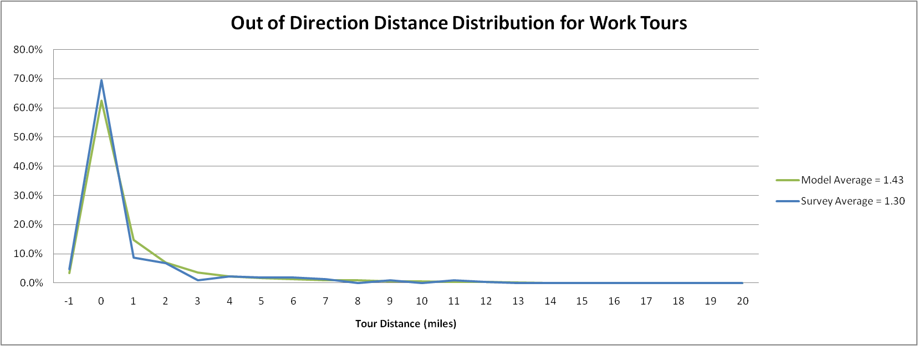

Figure : Work Stop Location Choice Calibration

The calibration constants for the university tour stop location choice model are shown in Table 36. As with the work stop location choice model, constants were used for out-of-direction distances less than zero and less than one, and the natural log of the out-of-direction distance was used for distances greater than one mile. Once the smaller distance categories were calibrated the model was able to closely match the higher out-of-direction distances without any additional calibration, so that constant was kept at zero.

Table : University Stop Location Choice Calibration Constants

|  |  |  |
| --- | --- | --- |
| **Out-of-Direction Distance** | **Calibration Term** | **Calibration Constant** |
| -1 - 0 miles | 1 | -1.9035 |
| 0 – 1 miles | 1 | -0.1827 |
| 1 + miles | LN(Distance + 1) | 0 |

The calibration results for the university stop location choice model are shown in Figure 25. The out-of-direction distance frequencies are a close match to the survey frequencies, and the average out of direction distance is only 0.39 miles different (1.25 miles from the weighted survey and 0.86 miles from the model).

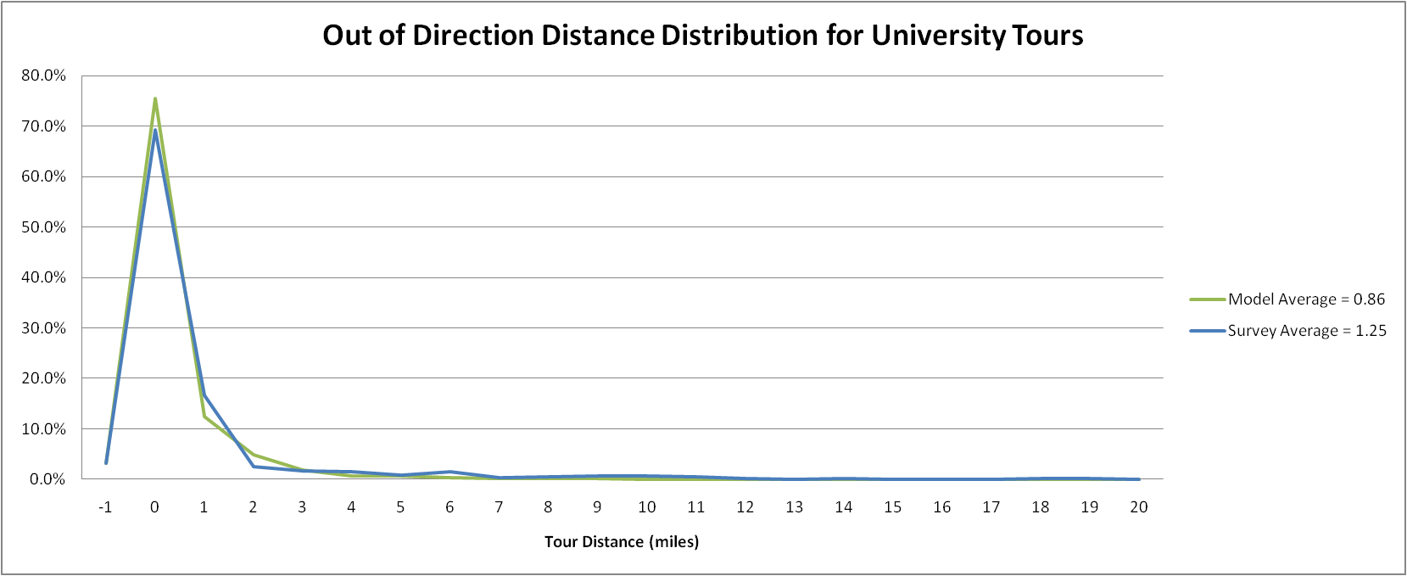

Figure : University Stop Location Choice Calibration

The maintenance stop location choice calibration constants are shown in Table 37. Constants were again used for out-of-direction distances less than zero and less than one, and the natural log of the out-of-direction distance was used for stops greater than one mile out of the way. The very large negative constant on the negative out-of-direction distance category indicates that the model was originally over-estimating the share of stops in that category. The survey reported less than 1% of maintenance stops in the negative out-of-direction distance category, so a large negative coefficient had to be used to match that low share.

Table : Maintenance Stop Location Choice Calibration Constants

|  |  |  |
| --- | --- | --- |
| **Out-of-Direction Distance** | **Calibration Term** | **Calibration Constant** |
| -1 - 0 miles | 1 | -10.5408 |
| 0 – 1 miles | 1 | 4.7523 |
| 1 + miles | LN(Distance + 1) | 0.6413 |

The stop location choice calibration results for maintenance tours are shown in Figure 26. Maintenance tours had some higher distances with a small number of trips, so the model fit is not as close as for some of the other purposes. The average out-of-direction distance from the survey is 2.35 miles, and the average distance at the end of the model calibration process was 1.82 miles.

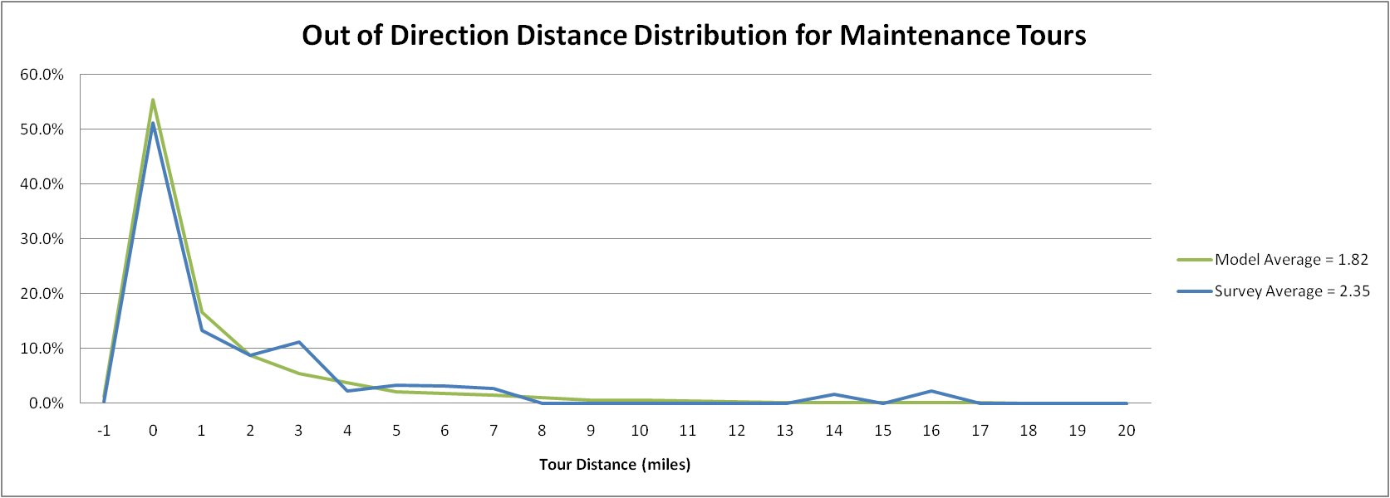

Figure : Maintenance Stop Location Choice Calibration

The choice calibration constants for the discretionary stop location choice model are shown in Table 38. Constants were again used for out-of-direction distances less than zero and less than one, and the natural log of the out-of-direction distance was used for stops greater than one mile out of the way. The very large positive constants on the negative and fractional out-of-direction distance categories indicate that the model was originally under-estimating stops in these categories. The survey reported nearly 12% of discretionary stops to have negative out-of-direction distances. This share was too large for the model to match given the sampling procedure used in selecting stop locations, so a large positive coefficient was asserted knowing that there would still be some error in the final calibration. As with the university stop location choice model once the constants were asserted for the smaller distances, the frequency distribution for higher out-of-direction distance values was quite close without any additional calibration.

Table : Discretionary Stop Location Choice Calibration Constants

|  |  |  |
| --- | --- | --- |
| **Out-of-Direction Distance** | **Calibration Term** | **Calibration Constant** |
| -1 - 0 miles | 1 | 11.7551 |
| 0 – 1 miles | 1 | 5.0754 |
| 1 + miles | LN(Distance + 1) | 0 |

The results of the stop location choice calibration for discretionary tours are in Figure 27. Although discretionary tours had fewer high-distance outliers than the other tour purposes, the high number of negative out-of-direction distance stops in the survey could not be matched in the model, which changed the overall calibration process. The model was calibrated to match the distances less than 1 mile as closely as possible and to have a slightly higher share than was in the survey for higher distances. The average out-of-direction distance from the survey of 1.15 miles is lower than the distance from the model of 1.71 miles, most likely due to the problems encountered in matching the high share of stops with a negative out-of-direction distance.

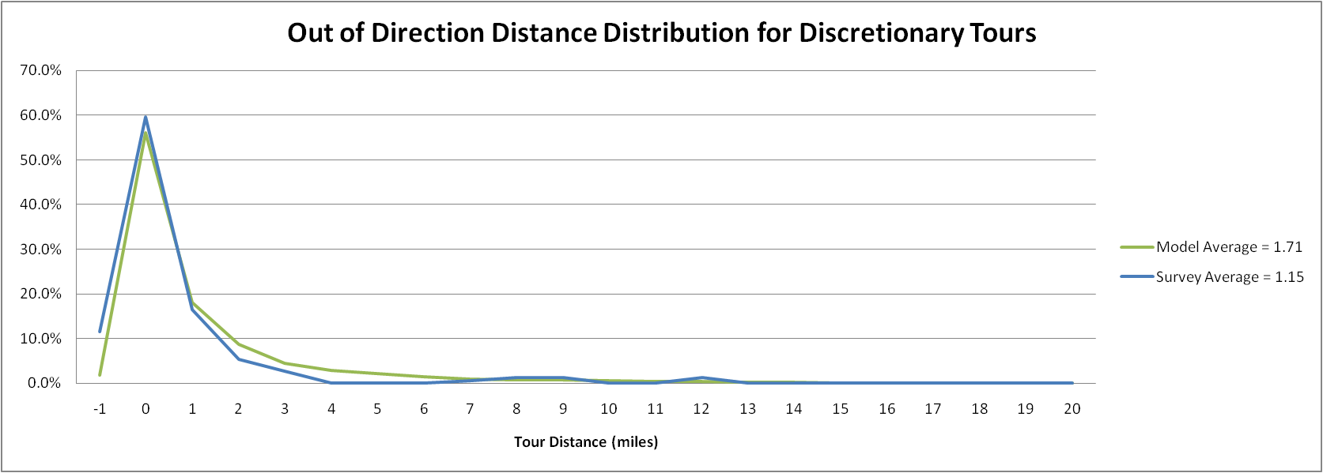

Figure : Discretionary Stop Location Choice Calibration

## Stop Departure Time Choice Model

The departure time choice for each stop is determined by simulating from an observed probability distribution. The distribution is segmented by direction (whether the stop is on an outbound journey or an inbound journey), the stop number, and the amount of time remaining on the tour based upon the last known trip time and the tour arrival time. So for example, if there stop departure time is being simulated for the first stop on an outbound journey which departs in period 14 and arrives in period 16, there are three possible departure times for the stop (period 14, period 15 or period 16). The distribution provides a probability for each possible period, using an offset from the last known time period approach (last known period, last known period + 1, last known period + 2). There are too many alternatives to display the probability distributions graphically.

## Trip Mode Choice Model

The trip mode choice model was not estimated, but it was calibrated separately from the tour mode choice model.

### Calibration Targets

The trip mode choice model attempted to match the trip mode shares by tour mode and trip purpose. To ensure there were a sufficient number of observations in each category the tour modes were combined in to university and non-university tours. The calibration targets are shown in Table 39 for non-university tours and in Table 40 for university tours. All percentages are by tour mode (across the row).

Table 39: Trip Mode Shares by Tour Mode for Non-University Tours

|  |  |  |  |  |  |  |  |  |  |
| --- | --- | --- | --- | --- | --- | --- | --- | --- | --- |
| **Tour Mode** | **Trip Mode** | | | | | | | | |
| **Drive Alone** | **HOV 2** | **HOV 3+** | **Walk** | **Bike** | **Walk to Local** | **Walk to BRT** | **PNR** | **KNR** |
| Drive Alone | 91.9% | -- | -- | 8.1% | -- | -- | -- | -- | -- |
| HOV2 | 12.7% | 76.7% | -- | 10.6% | -- | -- | -- | -- | -- |
| HOV3+ | 11.0% | 15.0% | 66.9% | 7.1% | -- | -- | -- | -- | -- |
| Walk | -- | -- | -- | 100.0% | -- | -- | -- | -- | -- |
| Bike | -- | -- | -- | 11.9% | 88.1% | -- | -- | -- | -- |
| Walk to Transit | -- | 15.8% | -- | 34.3% | 2.6% | 17.6% | 29.7% | -- | -- |
| PNR | -- | -- | -- | -- | -- | -- | -- | -- | -- |
| KNR | -- | 17.5% | -- | -- | -- | -- | -- | -- | 82.5% |

Table 40: Trip Mode Shares by Tour Mode for University Tours

|  |  |  |  |  |  |  |  |  |  |
| --- | --- | --- | --- | --- | --- | --- | --- | --- | --- |
| **Tour Mode** | **Trip Mode** | | | | | | | | |
| **Drive Alone** | **HOV 2** | **HOV 3+** | **Walk** | **Bike** | **Walk to Local** | **Walk to BRT** | **PNR** | **KNR** |
| Drive Alone | 85.1% | -- | -- | 14.9% | -- | -- | -- | -- | -- |
| HOV2 | 9.0% | 53.3% | -- | 37.7% | -- | -- | -- | -- | -- |
| HOV3+ | 3.0% | 3.9% | 46.6% | 46.5% | -- | -- | -- | -- | -- |
| Walk | -- | -- | -- | 100.0% | -- | -- | -- | -- | -- |
| Bike | -- | -- | -- | 25.3% | 74.7% | -- | -- | -- | -- |
| Walk to Transit | -- | 8.5% | -- | 37.2% | 1.7% | 27.3% | 25.4% | -- | -- |
| PNR | 20.5% | -- | -- | 19.6% | -- | -- | -- | 59.8% | -- |
| KNR | -- | -- | -- | 75.0% | -- | -- | -- | -- | 25.0% |

Tour and trip mode combinations shaded in grey in the tables were not permitted due to the mode choice hierarchy discussed in the Tour and Trip Mode section. Combinations that have no value but are not grey are possible but were not seen in the student travel survey. The walk to local and walk to premium trip modes were combined for calibration. The split between local and premium transit trips will be calibrated separately using the on-board transit survey.

### Calibration Results

Table 41 shows the calibration constants for the trip mode choice model for non-university tours. Constants that were set to -999 were either prohibited (someone on a PNR tour cannot have a bike trip because they would not have a bike available) or they were not seen in the survey. Tour and trip mode combinations shown in grey with a zero calibration constant were already prohibited by the model, so the constant was left at 0 since they were not a possibility. The diagonals (where the tour mode and trip mode are the same) were left at 0, and calibration constants were calculated relative to that base combination for each tour mode.

Table : Trip Mode Choice Calibration Constants for Non-University Tours

|  |  |  |  |  |  |  |  |  |  |
| --- | --- | --- | --- | --- | --- | --- | --- | --- | --- |
| **Tour Mode** | **Trip Mode** | | | | | | | | |
| **Drive Alone** | **HOV 2** | **HOV 3+** | **Walk** | **Bike** | **Walk to Local** | **Walk to BRT** | **PNR** | **KNR** |
| Drive Alone | 0 | 0 | 0 | -2.29 | 0 | 0 | 0 | 0 | 0 |
| HOV2 | -1.15 | 0 | 0 | -2.12 | 0 | 0 | 0 | 0 | 0 |
| HOV3+ | -1.44 | -0.89 | 0 | -3.40 | 0 | 0 | 0 | 0 | 0 |
| Walk | 0 | 0 | 0 | 0 | 0 | 0 | 0 | 0 | 0 |
| Bike | 0 | 0 | -999 | 0.0061 | 0 | 0 | 0 | 0 | 0 |
| Walk to Transit | 0 | -2.99 | -999 | -0.75 | -3.54 | 0 | 0 | 0 | 0 |
| PNR | -999 | -999 | -999 | -9 | -999 | -999 | -999 | 0 | -999 |
| KNR | -999 | -8.86 | -999 | -999 | -999 | -999 | -999 | -999 | 0 |

The calibration constants for the university trip mode choice model are in Table 42. This calibration used the same process, so the diagonals were kept at zero as well as any tour and trip mode combinations prohibited by the model.

Table : Trip Mode Choice Calibration Constants for University Tours

|  |  |  |  |  |  |  |  |  |  |
| --- | --- | --- | --- | --- | --- | --- | --- | --- | --- |
| **Tour Mode** | **Trip Mode** | | | | | | | | |
| **Drive Alone** | **HOV 2** | **HOV 3+** | **Walk** | **Bike** | **Walk to Local** | **Walk to BRT** | **PNR** | **KNR** |
| Drive Alone | 0 | 0 | 0 | -2.05 | 0 | 0 | 0 | 0 | 0 |
| HOV2 | -1.13 | 0 | 0 | 0.25 | 0 | 0 | 0 | 0 | 0 |
| HOV3+ | -2.16 | -1.45 | 0 | 0.77 | 0 | 0 | 0 | 0 | 0 |
| Walk | 0 | 0 | 0 | 0 | 0 | 0 | 0 | 0 | 0 |
| Bike | 0 | -3.41 | -5.252 | 0.84 | 0 | 0 | 0 | 0 | 0 |
| Walk to Transit | 0 | -4.14 | -999 | -0.99 | -4.55 | 0 | 0 | 0 | 0 |
| PNR | -3.20 | -999 | -999 | -0.12 | -999 | -999 | -999 | 0 | -999 |
| KNR | -999 | -150 | -999 | 4.71 | -999 | -999 | -999 | -999 | 0 |

The results of the trip mode choice calibration for non-university tours are shown in Table 43 and Table 44. Table 43 shows the difference in the total number of students selecting each tour-trip mode combination, and Table 44 shows the difference in the shares of students selecting each trip mode by tour mode. As the tables show, the shares for all modes are within 5% of the survey values with the exception of the walk to local and walk to premium, which were calibrated together. The combined share for walk to transit is within 5% of the survey share for all tour modes.

Table : Trip Mode Choice Absolute Difference (Model – Survey) for Non-University Tours

|  |  |  |  |  |  |  |  |  |  |
| --- | --- | --- | --- | --- | --- | --- | --- | --- | --- |
| **Tour Mode** | **Trip Mode** | | | | | | | | |
| **Drive Alone** | **HOV 2** | **HOV 3+** | **Walk** | **Bike** | **Walk to Local** | **Walk to BRT** | **PNR** | **KNR** |
| Drive Alone | 0 |  |  | 0 |  |  |  |  |  |
| HOV2 | -66 | 97 |  | -31 |  |  |  |  |  |
| HOV3+ | -1 | 43 | -27 | -15 |  |  |  |  |  |
| Walk |  |  |  | 0 |  |  |  |  |  |
| Bike |  |  |  | 8 | -8 |  |  |  |  |
| Walk to Transit |  | -42 |  | -34 | -6 | 20 | 62 |  |  |
| PNR |  |  |  |  |  |  |  |  |  |
| KNR |  | 4 |  |  |  |  |  |  | -4 |

Table 44: Trip Mode Choice Share Difference (Model – Survey) for Non-University Tours

|  |  |  |  |  |  |  |  |  |  |
| --- | --- | --- | --- | --- | --- | --- | --- | --- | --- |
| **Tour Mode** | **Trip Mode** | | | | | | | | |
| **Drive Alone** | **HOV 2** | **HOV 3+** | **Walk** | **Bike** | **Walk to Local** | **Walk to BRT** | **PNR** | **KNR** |
| Drive Alone | 0.0% |  |  | 0.0% |  |  |  |  |  |
| HOV2 | -0.8% | 1.2% |  | -0.4% |  |  |  |  |  |
| HOV3+ | -0.1% | 4.8% | -3.0% | -1.7% |  |  |  |  |  |
| Walk |  |  |  | 0.0% |  |  |  |  |  |
| Bike |  |  |  | 0.2% | -0.2% |  |  |  |  |
| Walk to Transit |  | -1.2% |  | -1.0% | -0.2% | 0.6% | 1.8% |  |  |
| PNR |  |  |  |  |  |  |  |  |  |
| KNR |  | 2.5% |  |  |  |  |  |  | -2.5% |

For both university and non-university tour purposes the trip and tour mode combinations that were not possible or were not seen in the survey were given a highly negative constant in the utility calculation to ensure that they were not chosen in the model application. The only exception to this was the combination of KNR tour mode and HOV 2 trip mode for university tours. This combination was not seen in the survey, but the only other trip mode possibilities (walk and KNR) were not available for some trips. Therefore, as shown in Table 45 and Table 46 some of the KNR tours do have HOV 2 trips. As with the Non-University Tours, Table 45 shows the absolute difference in the number of students choosing each tour and trip mode combination while Table 46 shows the difference in the share of students choosing each trip mode by tour mode. With the exception of that combination all other trip-tour mode combinations were within 5% of the survey shares at the end of the calibration process.

Table : Trip Mode Choice Absolute Difference (Model – Survey) for University Tours

|  |  |  |  |  |  |  |  |  |  |
| --- | --- | --- | --- | --- | --- | --- | --- | --- | --- |
| **Tour Mode** | **Trip Mode** | | | | | | | | |
| **Drive Alone** | **HOV 2** | **HOV 3+** | **Walk** | **Bike** | **Walk to Local** | **Walk to BRT** | **PNR** | **KNR** |
| Drive Alone | -23 |  |  | 23 |  |  |  |  |  |
| HOV2 | 15 | 18 |  | -33 |  |  |  |  |  |
| HOV3+ | 0 | 3 | -1 | -2 |  |  |  |  |  |
| Walk |  |  |  | 0 |  |  |  |  |  |
| Bike |  |  |  | -52 | 52 |  |  |  |  |
| Walk to Transit |  | -160 |  | -21 | -13 | -319 | 513 |  |  |
| PNR | -2 |  |  | 7 |  |  |  | -5 |  |
| KNR |  | 14 |  | -19 |  |  |  |  | 5 |

Table 46: Trip Mode Choice Share Difference (Model – Survey) for University Tours

|  |  |  |  |  |  |  |  |  |  |
| --- | --- | --- | --- | --- | --- | --- | --- | --- | --- |
| **Tour Mode** | **Trip Mode** | | | | | | | | |
| **Drive Alone** | **HOV 2** | **HOV 3+** | **Walk** | **Bike** | **Walk to Local** | **Walk to BRT** | **PNR** | **KNR** |
| Drive Alone | -0.4% |  |  | 0.4% |  |  |  |  |  |
| HOV2 | 0.2% | 0.2% |  | -0.4% |  |  |  |  |  |
| HOV3+ | 0.0% | 0.6% | -0.3% | -0.4% |  |  |  |  |  |
| Walk |  |  |  | 0.0% |  |  |  |  |  |
| Bike |  |  |  | -0.4% | 0.4% |  |  |  |  |
| Walk to Transit |  | -1.3% |  | -0.2% | -0.1% | -2.6% | 4.2% |  |  |
| PNR | -0.3% |  |  | 0.9% |  |  |  | -0.7% |  |
| KNR |  |  |  | -4.2% |  |  |  |  | 1.2% |

Table 47 shows a comparison of the current ridership levels by transit access mode and line-haul mode from the model and from the 2011 On Board survey for student travel. The local/premium designation is only included for walk/bike access because the model does not differentiate between local and premium service for drive access modes. The totals are close when only considering access mode, but the model predicts too many passengers on premium transit and not enough using local. A small adjustment is required to the shares of local and premium transit using the walk access mode to ensure that the ridership levels match the 2011 On Board Survey.

Table : Transit Ridership Comparison Model vs. 2011 On Board Survey

|  |  |  |
| --- | --- | --- |
| **Trip Mode** | **University Model** | **2011 On Board Survey** |
| Walk/Bike to Local | 3,668 | 5,485 |
| Walk/Bike to Premium | 4,726 | 2,528 |
| Walk/Bike to Transit (Total) | 8,394 | 8,013 |
| PNR | 463 | 598 |
| KNR | 239 | 218 |
| All Transit | 9,096 | 8,829 |

# University Model User’s Guide

The university model is implemented in Java software, using the PB Common Modeling Framework library of tools. The model relies upon skims provided from any commercial transport software package including EMME or VISUM, and can be configured to write trip tables to EMME databanks or matrix formats, or VISUM matrices. It is currently set up to read EMME matrices for the Eugene region.

The following software is required to execute the university model.

• Java

The University model utilizes the open- source Java Common Modeling Framework (CMF) software developed by Parsons Brinckerhoff. The 64-bit Java Runtime Environment (version 1.7 or later) must be installed on the computer. The 64-bit version of the software allows the software to take advantage of larger memory addresses.

• GNU tools

The travel model utilizes a tool provided by the GNU free software foundation to redirect, or “pipe”, output from a DOS process (specifically Java) to a text file. This is useful in case the java process terminates in an error, as the text file can be opened to determine what the error might have been. The GNU Win32 tools can be downloaded from sourceforge.net (http://gnuwin32.sourceforge.net/).

• Microsoft Excel (not required but helpful)

The discrete choice models are specified via spreadsheets, referred to as Utility Expression Calculators or UECs. These files are Excel-based. See Appendix for a more detailed explanation on these Excel files. It is helpful to have Excel installed so that the spreadsheets can be opened, though it is not essential for running the model system.

## Input Files

There are a number of input files required for running the model. They are organized into the following categories: Data Inputs, Model Specifications, Programs, and Properties Files.

#### Data Inputs

The following data inputs are required to run the University Model:

* Synthetic household and person files: The residential location choice model is implemented in a stand-alone spreadsheet, and provides constraints to the population synthesizer which is implemented separately. It is assumed that these processes have been run prior to running the University Model.
* Public Use Microdata files: Both household and person files from Census PUMS data are read in by the University Model program, and are used to create the group quarters synthetic population.
* TAZ data file: The TAZ data file contains households by type, employment by type, and a number of other fields that are necessary to run the University model.
* Travel time and cost skims: a set of time and cost skims are used for calculation of accessibilities, mode, and destination choice models.

The full list of data inputs is given in Table 48.

Table 48: Data Inputs

|  |  |
| --- | --- |
| **File Name** | **Description** |
| ss11pLCOGWithZeros.csv | 2011 ACS PUMS Person File, with zeros for missing integer fields and N.A. for missing text fields. This file is not year-specific or scenario-specific. |
| ss11hLCOGWithZeros.csv | 2011 ACS PUMS Household File, with zeros for missing integer fields and N.A. for missing text fields. This file is not year-specific or scenario-specific. |
| persons_clean.csv | Synthetic population person file; year-specific or land-use scenario specific. |
| households_clean.csv | Synthetic population household file; year-specific or land-use scenario specific. |
| tazData.csv | Input TAZ data file; year-specific or land-use scenario specific. Fields and description are given in Table 27. |
| Emmebank | An EMME databank containing matrices as shown in Table 29. |

Table 49: TAZ Data File Fields

|  |  |
| --- | --- |
| **Field Name** | **Description** |
| TAZ | LCOG TAZ ID for the zone |
| TD | Not Used |
| SF | Number of Single Family households in the zone |
| Duplex | Number of Duplexes in the zone |
| MF | Number of Multi-Family households in the zone |
| MH | Number of Mobile Homes in the zone |
| TotalHH | Total number of households in the zone |
| Food_Emp | Number of employees in the food manufacturing industry |
| OthDur_Emp | Number of employees working in non-food durable goods manufacturing |
| OthNonDur_Emp | Number of employees working in non-durable goods manufacturing |
| Constr_Emp | Number of employees in the construction industry |
| TCU_Emp | Number of employees working in transportation, communications, and utilities |
| Wholesale_Emp | Number of employees working in wholesale |
| FIRE_Emp | Number of employees working in finance, insurance, or real estate |
| GenRetail_Emp | Number of employees working at retail establishments that are local attractors |
| GenServ_Emp | Number of employees working at service establishments that are local attractors |
| MajRet_Emp | Number of employees working at retail establishments that are regional attractors |
| MajSvc_Emp | Number of employees working at service establishments that are regional attractors |
| TempGrp_Emp | Number of employees working in temporary housing (i.e. hotels, motels, etc.) |
| Lumber_Emp | Number of employees working in the lumber industry |
| Mining_Emp | Number of employees working in the mining industry |
| Federal_Emp | Number of federal government employees |
| StateLocGov_Emp | Number of state and local government employees |
| StateLocEduc_Emp | Number of state and local education employees |
| Agric_Emp | Number of employees working in agriculture |
| Other_Emp | All other employees |
| TotalEmp | Total employment |
| GQ | Number of group quarters housing units |
| GQType | Type of group quarters housing |
| universitySqFt | Number of square feet of University of Oregon classroom space |

Table 50: Level-of-Service Skims

|  |  |
| --- | --- |
| **Field Name** | **Description** |
| mf12 | Walk Time – AM Peak |
| mf17 | Bike Time – AM Peak |
| mf19 | Drive Alone No-Toll Time – AM Peak |
| mf04 | Drive Alone No-Toll Distance – AM Peak |
| mf19 | Shared Ride 2 No-Toll Time – AM Peak |
| mf04 | Shared Ride 2 No-Toll Distance – AM Peak |
| mf19 | Shared Ride 3+ No-Toll Time – AM Peak |
| mf04 | Shared Ride 3+ No-Toll Distance – AM Peak |
| mf20 | Walk to Local Transit In-Vehicle Time – AM Peak |
| mf23 | Walk to Local Transit First-Wait Time – AM Peak |
| mf22 | Walk to Local Transit Total Wait Time – AM Peak |
| mf21 | Walk to Local Transit Walk Time – AM Peak |
| ms53 | Walk to Local Transit Fare – AM Peak |
| mf24 | Walk to Local Transit Boardings – AM Peak |
| mf25 | Walk to Premium Transit In-Vehicle Time – AM Peak |
| mf28 | Walk to Premium Transit First-Wait Time – AM Peak |
| mf27 | Walk to Premium Transit Total Wait Time – AM Peak |
| mf26 | Walk to Premium Transit Walk Time – AM Peak |
| ms53 | Walk to Premium Transit Fare – AM Peak |
| mf29 | Walk to Premium Transit Boardings – AM Peak |
| mf30 | PNR In-Vehicle Time – AM Peak |
| mf33 | PNR First Wait Time – AM Peak |
| mf32 | PNR Total Wait Time – AM Peak |
| mf31 | PNR Walk Time – AM Peak |
| mf40 | PNR Drive Time – AM Peak |
| ms53 | PNR Fare – AM Peak |
| mf34 | PNR Boardings – AM Peak |
| ms51 | PNR Formal Indicator – AM Peak |
| mf35 | KNR In-Vehicle Time – AM Peak |
| mf38 | KNR First Wait Time – AM Peak |
| mf37 | KNR Total Wait Time – AM Peak |
| mf36 | KNR Walk Time – AM Peak |
| mf41 | KNR Drive Time – AM Peak |
| ms53 | KNR Fare – AM Peak |
| mf39 | KNR Boardings – AM Peak |
| mf250 | Walk Time – PM Peak |
| mf258 | Bike Time – PM Peak |
| mf102 | Drive Alone No-Toll Time – PM Peak |
| mf04 | Drive Alone No-Toll Distance – PM Peak |
| mf102 | Shared Ride 2 No-Toll Time – PM Peak |
| mf04 | Shared Ride 2 No-Toll Distance – PM Peak |
| mf102 | Shared Ride 3+ No-Toll Time – PM Peak |
| mf04 | Shared Ride 3+ No-Toll Distance – PM Peak |
| mf107 | Walk to Local Transit In-Vehicle Time – PM Peak |
| mf109 | Walk to Local Transit First-Wait Time – PM Peak |
| mf190 | Walk to Local Transit Total Wait Time – PM Peak |
| mf108 | Walk to Local Transit Walk Time – PM Peak |
| mf10 | Walk to Local Transit Fare – PM Peak |
| mf218 | Walk to Local Transit Boardings – PM Peak |
| mf228 | Walk to Premium Transit In-Vehicle Time – PM Peak |
| mf230 | Walk to Premium Transit First-Wait Time – PM Peak |
| mf231 | Walk to Premium Transit Total Wait Time – PM Peak |
| mf229 | Walk to Premium Transit Walk Time – PM Peak |
| mf10 | Walk to Premium Transit Fare – PM Peak |
| mf232 | Walk to Premium Transit Boardings – PM Peak |
| mf233 | PNR In-Vehicle Time – PM Peak |
| mf235 | PNR First Wait Time – PM Peak |
| mf236 | PNR Total Wait Time – PM Peak |
| mf234 | PNR Walk Time – PM Peak |
| mf238 | PNR Drive Time – PM Peak |
| mf10 | PNR Fare – PM Peak |
| mf237 | PNR Boardings – PM Peak |
| ms51 | PNR Formal Indicator – PM Peak |
| mf242 | KNR In-Vehicle Time – PM Peak |
| mf246 | KNR First Wait Time – PM Peak |
| mf247 | KNR Total Wait Time – PM Peak |
| mf243 | KNR Walk Time – PM Peak |
| mf249 | KNR Drive Time – PM Peak |
| mf10 | KNR Fare – PM Peak |
| mf248 | KNR Boardings – PM Peak |
| mo30 | Household Density |
| md05 | Parking Cost |
| md02 | Terminal Time |

#### Model Specifications

The University model is specified in a set of Excel workbooks referred to as Utility Expression Calculators (UECs), and observed probability distributions. The model specifications are listed in Table 51 in order of use by model component.

Table 51: UECs and Observed Probability Distributions

|  |  |
| --- | --- |
| **UEC File** | **Description (UEC file for)** |
| UniversityAccessibilities.xls | Origin-based accessibility specification. |
| UniversityAutoOwnership.xls | Auto ownership model. |
| UniversityTourFrequencyGQ.csv | University tour frequency distribution for students living in group quarters. |
| UniversityTourFrequencyNonFamily.csv | University tour frequency distribution for students living in non-family households. |
| UniversityTourFrequencyFamily.csv | University tour frequency distribution for students living in family households. |
| UniversityTourDestinationChoiceSOAAlternatives.csv | A list of the tour destination choice alternatives for the initial sampling of alternatives model (should equal the number of TAZs in the model area) |
| UniversityTourDestinationChoiceAlternatives.csv | A list of the number of tour destination choice alternatives to sample (currently set to 30, for 30 sampled TAZs from the full set) |
| UniversityTourDestinationChoiceSOA.xls | University Tour Destination Choice Sample of Alternatives UEC. Note that this UEC includes size terms for tour and stop destination choice models, as well as those used in the accessibility calculations. |
| UniversityTourDestinationChoice.xls | University Tour Destination Choice Full Model UEC |
| UniversityTourTimeOfDayDistributions.csv | Observed probability distributions for university tour time-of-day choice. |
| UniversityTourModeChoice.xls | University Tour Mode Choice UEC. |
| UniversityStopFrequencyDistributions.csv | University Stop Frequency Distributions by tour purpose, duration, and number of inbound/outbound stops |
| UniversityStopPurposeDistributions.csv | University Stop Purpose Distributions by tour purpose, inbound stop, stop number, multiple stops on tour indicator. |
| UniversityStopLocationChoiceSOA.xls | University Stop Location Choice Sample of Alternatives UEC |
| UniversityStopLocationChoice.xls | University Stop Location Choice Full Model UEC |
| UniversityStopLocationChoiceAlternatives.csv | List of University Stop Location Choice Alternatives for Full Model (15) |
| UniversityOutboundStopDurationDistributions.csv | University stop duration distributions for stops on outbound journeys |
| UniversityInboundStopDurationDistributions.csv | University stop duration distributions for stops on inbound journeys |
| UniversityTripModeChoice.xls | University Trip Mode Choice UEC |

#### Model Programs & Running the Model

There are a few programs and batch files required in order to run the university model, as listed in Table 52. The batch file that runs the university model is ‘runUniversityModel.cmd’. This batch file takes four arguments, as follows:

Argument 1: The project drive

Argument 2: The project directory

Argument 3: The sample rate

Argument 4: The iteration number

An example of running the batch file would be as follows:

runUniversityModel.cmd d: /projects/Oregon_DOT/2011_OnCall_Services/application/UofO/Database 1.0 1

This tells the program that the scenario directory is on the d: drive in the directory \projects\Oregon_DOT\2011_OnCall_Services\application\UofO\Database. Note the use of forward slashes in the path instead of backward slashes; java uses forward slashes by convention. The sample rate of 1.0 indicates that a 100% sample is to be run. The sample rate can be any floating point number between 0 and 1.0; each output record (see Outputs, below) has an expansion factor that can be used to scale the record up to the full population. The iteration number is currently ignored.

Table 52: Program Files

|  |  |
| --- | --- |
| **Program** | **Description** |
| CTRampEnv.bat | Sets the location of java, and the GNU win32 tools |
| tpau.jar | Compiled java code needed to run the university model |
| runUniversityModel.cmd | List of MS-DOS instructions that control model flow. This is the batch file that is called to run the university model. |

#### Property Files

There are two property files read by the University model:

* Tpau_tbm.properties: This is the main property files which lists general settings such as the number of time periods in the model, as well as properties specific to each particular model component, such as the location of input UECs or observed distributions, the page number for the data specification in that Excel file, and for each model component. The model is highly-configurable by changing properties specified in this file, but it is not recommended to change most properties without familiarity with the underlying code. The properties file is fairly well-commented. For example, in order to change the person\household traced through the model, change the HouseholdManager.debug.HouseholdIds setting to list the households to trace.
* Log4j.xml: This property file controls logging for each model component. The university model uses log4j, a third-party logging tool in Java, for reporting during model runs. By modifying this file, the user can send different logging to different report files, and also control whether those files are appended to or overwritten each time the model is run. Currently the file is configured to send logging to either the event.log file or the universityModel.log file (most logging is sent to this latter file, including all debugging/tracing of specific agents in the model system). It is not recommended to change this file.

## Output Files

There are five key output files from the model system, listed below.

• Accessbilities.csv: A zone-based file with origin-based accessibilities by purpose and mode or segment, as described above.

• Households.csv: A household output file with variables coded from the input synthetic population file.

• Persons.csv: A person output file with variables coded from the input synthetic population file, as well as chosen work TAZ and school TAZ for workers and students, the auto availability choice for the person, and the total number of tours generated by that person.

• Tours.csv: A tour output file listing the tours generated by each person in each household. This includes the purpose of the tour, the time the person departed on the tour (in 15 minute increments starting at 3:00AM), the time the person arrived at the primary destination of the tour, the origin and primary destination TAZ of the tour, the primary mode of the tour, and the number of outbound and inbound stops on the tour. Also for all stops on the tour, the information about each stop is generated, i.e. stop is inbound (inbound = 1) or outbound (inbound = 0), mode used for that stop (see Trip Mode below), the time period, TAZ of the stop, and purpose of the stop (same code as tour purpose).

• Trips.csv: A trip output file listing all trips made on each the tour by each person in each household. This includes the origin and destination TAZ of the trip, trip mode (see code below), origin and destination purpose, period of the trip (30 minute increments starting at 3:00AM), whether the trip was inbound (inbound = 1) or outbound (inbound = 0), whether the trip is the first of the tour (firsttrip = 1), or last of the tour (lasttrip = 1), and whether origin or destination is the primary destination of the tour.

Table 53: Accessibilities file fields

|  |  |
| --- | --- |
| **Field Name** | **Description** |
| Maintenance_SOV | Accessibility to Maintenance activities by SOV |
| Maintenance_HOV | Accessibility to Maintenance activities by HOV |
| Maintenance_WALKTRAN | Accessibility to Maintenance activities by Walk-Transit |
| Maintenance_WALK | Accessibility to Maintenance activities by Walk |
| Maintenance_AUSUF0 | Accessibility to Maintenance activities for 0 auto travelers |
| Maintenance_AUSUF1 | Accessibility to Maintenance activities for 1+ auto travelers |
| Maintenance_ALL | Accessibility to Maintenance activities for all travelers |
| Discretionary_SOV | Accessibility to Discretionary activities by SOV |
| Discretionary_HOV | Accessibility to Discretionary activities by HOV |
| Discretionary_WALKTRAN | Accessibility to Discretionary activities by Walk-Transit |
| Discretionary_WALK | Accessibility to Discretionary activities by Walk |
| Discretionary_AUSUF0 | Accessibility to Discretionary activities for 0 auto travelers |
| Discretionary_AUSUF1 | Accessibility to Discretionary activities for 1+ auto travelers |
| Discretionary_ALL | Accessibility to Discretionary activities for all travelers |
| AllEmp_SOV | Accessibility to all employment by SOV |
| AllEmp_HOV | Accessibility to all employment by HOV |
| AllEmp_WALKTRAN | Accessibility to all employment by Walk-Transit |
| AllEmp_WALK | Accessibility to all employment by Walk |
| AllEmp_AUSUF0 | Accessibility to all employment for 0 auto travelers |
| AllEmp_AUSUF1 | Accessibility to all employment for 1+ auto travelers |
| AllEmp_ALL | Accessibility to all employment for all travelers |
| AllHH_SOV | Accessibility to all households by SOV |
| AllHH_HOV | Accessibility to all households by HOV |
| AllHH_WALKTRAN | Accessibility to all households by Walk-Transit |
| AllHH_WALK | Accessibility to all households by Walk |
| AllHH_AUSUF0 | Accessibility to all households for 0 auto travelers |
| AllHH_AUSUF1 | Accessibility to all households for 1+ auto travelers |
| AllHH_ALL | Accessibility to all households for all travelers |

Table 54: Household file fields

|  |  |
| --- | --- |
| **Field Name** | **Description** |
| hh_id | Household ID |
| autos | Number of autos (in the case of the university model, this is the number of autos from the synthetic population, not the output from the auto ownership model) |
| workers | Number of workers in the household (from popsyn) |
| income | Household income (in $2011, from popsyn) |
| adults | Adults in household (from popsyn) |
| family | 1 if family household, else 0 (from popsyn) |
| taz | Household residence TAZ (from popsyn) |
| buildingType | Household building type (from popsyn); see Table 32 |
| debugChoiceModels | 1 if household was selected for debugging, else 0 |
| seed | Random number seed for household choice models |
| expansionFactor | Household expansion factor |

Table 55: Household building type

|  |  |
| --- | --- |
| **Code** | **Description** |
| 0 | Single Family |
| 1 | Townhouse |
| 2 | Apartment |
| 3 | Mobile home |
| 4 | Group quarters |

Table 56: Person file fields

|  |  |
| --- | --- |
| **Field Name** | **Description** |
| hh_id | Household ID |
| person_id | Person ID |
| female | 1 if female, else 0 |
| age | Age in years |
| occupation | Occupation of worker, see Table 35 |
| workStatus | Work status, see Table 37 |
| studentStatus | Student status, see Table 37 |
| majorUniversityStudent | 1 if major university student, else 0 |
| personType | Person type, see Table 39 |
| workTaz | Work TAZ if worker |
| schoolTaz | School TAZ if student |
| autoAvailable | Chosen auto availability; 1 if auto available, else 0 |
| parksFreeAtWork | Chosen free parking at work; 1 if parks free, else 0 |
| numberOfTours | Number of tours generated by person |
| seed | Random number seed for person choice models |
| expansionFactor | Expansion factor |

Table 57: Tour file fields

|  |  |
| --- | --- |
| **Field Name** | **Description** |
| hh_id | Household ID |
| person_id | Person ID |
| tour_id | Tour ID |
| purpose | Tour purpose, see Table 40 |
| departTime | Departure time period, see Table 42 |
| arriveTime | Arrival time period, see Table 42 |
| originTaz | Origin TAZ |
| destinationTaz | Primary destination TAZ |
| tourMode | Tour mode, see Table 43 |
| seed | Random number seed for tour and stop choice models |
| expansionFactor | Expansion factor |
| numberOutboundStops | Number of stops on outbound tour direction |
| numberInboundStops | Number of stops on inbound tour direction |
| numberTrips | Number of trips on tour |
| outstop_*n*_inbound | Outbound stop *n* inbound code (always 0) |
| outstop_*n*_mode | Mode of trip to outbound stop *n*, see Table 43 |
| outstop_*n*_period | Departure time period of outbound stop *n,* see Table 42 |
| outstop_*n*_taz | Outbound stop *n* TAZ |
| outstop_*n*_purpose | Outbound stop *n* purpose, see Table 40 |
| outstop_*n*_seed | Outbound stop *n* random number seed |
| instop_*n*_inbound | Inbound stop *n* inbound code (always 1) |
| instop_*n*_mode | Mode of trip to inbound stop *n*, see Table 43 |
| instop_*n*_period | Departure time period of inbound stop *n,* see Table 42 |
| instop_*n*_taz | Inbound stop *n* TAZ |
| instop_*n*_purpose | Inbound stop *n* purpose, see Table 40 |
| instop_*n*_seed | Inbound stop *n* random number seed |

Table 58: Trip file fields

|  |  |
| --- | --- |
| **Field Name** | **Description** |
| hh_id | Household ID |
| person_id | Person ID |
| tour_id | Tour ID |
| trip_id | Trip ID |
| expansionFactor | Expansion factor |
| originTaz | Departure time period, see Table 42 |
| destinationTaz | Arrival time period, see Table 42 |
| tripMode | Trip mode, see Table 43 |
| originPurpose | Purpose at origin end of trip, see Table 40 |
| destinationPurpose | Purpose at destination end of trip, see Table 40 |
| period | Departure period for trip, see Table 42 |
| inbound | 1 if trip occurs on inbound tour direction, else 0 |
| firstTrip | 1 if first trip on tour, else 0 |
| lastTrip | 1 if last trip on tour, else 0 |
| originIsTourDestination | 1 if trip origin is tour primary destination, else 0 |
| destinationIsTourDestination | 1 if trip destination is tour primary destination, else 0 |

Table 59: Occupation codes

|  |  |
| --- | --- |
| **Code** | **Description** |
| 0 | Management of business, science, and the arts |
| 1 | White collar |
| 2 | Blue collar |
| 3 | Sales and office |
| 4 | Natural resource extraction, construction, and maintenance |
| 5 | Production, transportation, material moving |
| 6 | Military |

Table 60: Work status codes

|  |  |
| --- | --- |
| **Code** | **Description** |
| 0 | Non-worker |
| 1 | Full-time worker |
| 2 | Part-time worker |

Table 61: Student status codes

|  |  |
| --- | --- |
| **Code** | **Description** |
| 0 | Non-student |
| 1 | Pre-kindergarten student |
| 2 | K-12 student |
| 3 | College student |

Table 62: Person type codes

|  |  |
| --- | --- |
| **Code** | **Description** |
| 0 | Full-time worker |
| 1 | Part-time worker |
| 2 | University student |
| 3 | Non-working adult |
| 4 | Retired adult |
| 5 | Driving age student |
| 6 | Pre-driving age student |
| 7 | Pre-school child |

Table 63: Purposes

|  |  |
| --- | --- |
| **Code** | **Description** |
| -1 | Home |
| 0 | Work |
| 1 | University |
| 2 | Maintenance |
| 3 | Discretionary |

Table 64: Time periods

|  |  |  |
| --- | --- | --- |
| **Code** | **Start of Period** | **End of Period** |
| 0 | 3:00 AM | 3:30 AM |
| 1 | 3:30 AM | 4:00 AM |
| 2 | 4:00 AM | 4:30 AM |
| 3 | 4:30 AM | 5:00 AM |
| 4 | 5:00 AM | 5:30 AM |
| 5 | 5:30 AM | 6:00 AM |
| 6 | 6:00 AM | 6:30 AM |
| 7 | 6:30 AM | 7:00 AM |
| 8 | 7:00 AM | 7:30 AM |
| 9 | 7:30 AM | 8:00 AM |
| 10 | 8:00 AM | 8:30 AM |
| 11 | 8:30 AM | 9:00 AM |
| 12 | 9:00 AM | 9:30 AM |
| 13 | 9:30 AM | 10:00 AM |
| 14 | 10:00 AM | 10:30 AM |
| 15 | 10:30 AM | 11:00 AM |
| 16 | 11:00 AM | 11:30 AM |
| 17 | 11:30 AM | 12:00 PM |
| 18 | 12:00 PM | 12:30 PM |
| 19 | 12:30 PM | 1:00 PM |
| 20 | 1:00 PM | 1:30 PM |
| 21 | 1:30 PM | 2:00 PM |
| 22 | 2:00 PM | 2:30 PM |
| 23 | 2:30 PM | 3:00 PM |
| 24 | 3:00 PM | 3:30 PM |
| 25 | 3:30 PM | 4:00 PM |
| 26 | 4:00 PM | 4:30 PM |
| 27 | 4:30 PM | 5:00 PM |
| 28 | 5:00 PM | 5:30 PM |
| 29 | 5:30 PM | 6:00 PM |
| 30 | 6:00 PM | 6:30 PM |
| 31 | 6:30 PM | 7:00 PM |
| 32 | 7:00 PM | 7:30 PM |
| 33 | 7:30 PM | 8:00 PM |
| 34 | 8:00 PM | 8:30 PM |
| 35 | 8:30 PM | 9:00 PM |
| 36 | 9:00 PM | 9:30 PM |
| 37 | 9:30 PM | 10:00 PM |
| 38 | 10:00 PM | 10:30 PM |
| 39 | 10:30 PM | 11:00 PM |
| 40 | 11:00 PM | 11:30 PM |
| 41 | 11:30 PM | 12:00 AM |
| 42 | 12:00 AM | 12:30 AM |
| 43 | 12:30 AM | 1:00 AM |
| 44 | 1:00 AM | 1:30 AM |
| 45 | 1:30 AM | 2:00 AM |
| 46 | 2:00 AM | 2:30 AM |
| 47 | 2:30 AM | 3:00 AM |

Table 65: Modes

|  |  |
| --- | --- |
| **Code** | **Description** |
| 1 | Drive-alone, general purpose |
| 2 | Drive-alone, toll-eligible |
| 3 | Shared ride 2, general purpose |
| 4 | Shared ride 2, toll-eligible |
| 5 | Shared ride 3+, general purpose |
| 6 | Shared ride 3+, toll-eligible |
| 7 | Walk |
| 8 | Bike |
| 9 | Walk-local transit |
| 10 | Walk-premium transit |
| 11 | Park-and-ride transit |
| 12 | Kiss-and-ride transit |

1. All size term coefficients shown in their exponentiated form, as they are used in the size term equation. The t-statistics provided were calculated based on the un-exponentiated values, which were negative, so the t-statistics are negative even where the exponentiated coefficients are positive.
2. Please note that the targets used in calibration is the total number of students in the TAZ – hence, the number of students in family and non-family housing as predicted by the model is added up before making comparisons.